**~~~BULLYING BEHAVIORS~~~**

**~USING POWER TO HURT SOMEONE~**

**~ON PURPOSE~**

**~OVER AND OVER AGAIN~**

**PHYSICAL ...to hurt body & p**

**BULLYING r**

hit **o**

kick **p**

punch **e**

push **r**

shove trip break **t**

steal throw bite **y**

spit poke break

tear rip

**SOCIAL BULLYING...to hurt friendships or reputation**

ganging up with

others to:

...spread rumors

...gossip & lies

...hurt with words

...exclude & leave others out on purpose …invite others to join an “I hate club”

…embarrass someone

Teasing someone…then saying, “I was just kidding. Can’t you take a joke!”

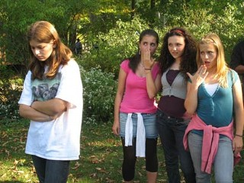

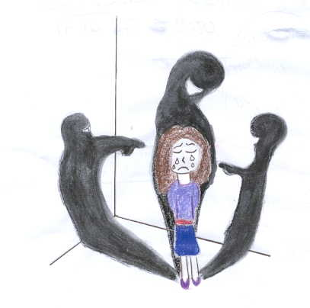



**CYBER-BULLYING**

using technology to hurt someone’s feelings, friendships, or reputation

~FaceBook ~ Twitter ~ Instagram ~

~ MySpace ~ cell phones ~

~ Online gaming ~

taking someone’s picture and texting it without permission

r u m o u r s

g

o l

s i

s e

i s

p

don’t forward, post or reply to rumors, gossip & lies REPORT IT !

**VERBAL BULLYING…to hurt feelings**

teasing

putdowns

name calling

insults

threats

swearing

rumors

gossip

lies How did your words

make him/her feel?

TEASING ME ABOUT: how I look, how much I weigh, how I dress, the clothes I wear, where I live, what I like to do, if I act like a girl, how I play sports, Who I pray to, my skin color, where I was born, the games & toys I like to play with, when I can’t do something as good as others, who I like, my stuff

For more info on bullying: visit my website: BCSD > McNamara > Staff pages >

Jeff Seltzer > “website”

