Joseph Koney is a
WHO
Ugandan warlord, and the leader of the Lord’s Resistance Army (LRA). His views are based on a mystical form of Christianity. Kony and most of his followers have been hiding out in jungle in Sudan since 2006 so they cannot be captured for their crimes.
Under Koney’s leadership, the goal of the LRA is to overthrow the Ugandan government. The LRA uses violence and fear to scare people into doing what it wants. They kidnapped many children and turned them into soldiers. Organizations like Koney’s make shaky African governments even more unstable.
WHAT
Joseph Kony, of the LRA, has become infamous almost overnight. This is because of a movie and social media campaign run by the organization Invisible Children. Invisible children is being criticized for spending too much of its money on media (more than half of what it raised), and not enough on the problem on the ground. It’s also been accused of exaggerating an old problem that isn’t as big of an issue anymore, as Kony fled Uganda in 2006. It’s very important to know that this is only ONE problem, and there are MANY other concerns in the world.
WHY
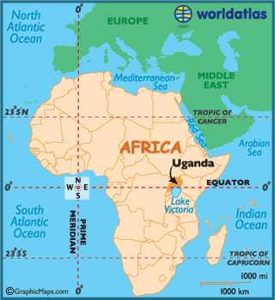
UGANDA
WHERE

