North Korea is run by a dictator. A famine started in the early 1990s, and since then many people have starved to death. The United Nations and the United States have provided free food to North Korea to help the starving people, but North Korea misuses this food aid, and instead of feeding ordinary citizens, the government uses it to feed its huge army. North Korea spends most of its money on trying to build nuclear bombs, but instead should spend its money on food.

North

Korea

Prior to 2002, Afghanistan was ruled by the Taliban. The Taliban is a fundamentalist Muslim organization linked to terrorism. Under the Taliban, women were whipped in the street for showing too much skin, prohibited from attending school, traveling, or going to work and driving without a male relative. Since the Taliban was overthrown in 2002, women have gained many important freedoms. Now, as the US withdraws from the area, there is a danger that the Taliban will return and women will suffer.

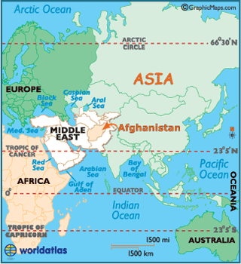

Afghanistan

Somalia has been fighting a civil war since 1991, and there is currently no central government. One group fighting for control is Al-Shabaab, an Islamist militant organization. The organization kidnaps children from their homes and schools, and uses them as soldiers and living shields on the battlefield. Children, between the ages of 10-17, are taught to throw grenades and use weapons. Many of them are assaulted, raped, and forced into marriages. Children are suffering.

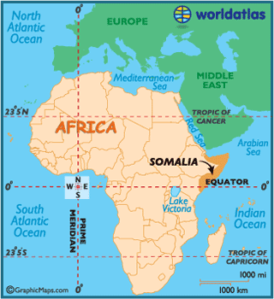
Somalia

Syria, like many other countries in the Middle East, experienced an uprising during the Arab Spring, a political movement that began in January of 2011. Civilians in Syria wanted the government to end its state of emergency (in effect since 1963) and reinstate civil rights. Over the past year, protests and demonstrations have continued to grow. The government hates the protests and the rebels, and it has killed over 7,600 people in an attempt to stop them. Many, many people are dying.

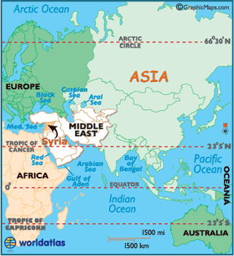
Syria

SOURCES:
KONY:

“Joseph Kony 2012: growing outrage in Uganda over film.” The Telegraph.

http://www.telegraph.co.uk/news/worldnews/africaandindianocean/uganda/9131469/Joseph-Kony-2012-growing-outrage-in-Uganda-over-film.html
“Invisible Children: Saviors or Sensationalists?” UN Dispatch
http://www.undispatch.com/invisible-children-saviors-or-sensationalists
NORTH KOREA:
“Stop feeding North Korea’s nuclear ambitions.” Washington Post.
http://www.washingtonpost.com/opinions/us-food-aid-to-n-korea-sends-the-wrong-messages/2012/03/07/gIQA6MM1zR_story.html
AFGHANISTAN:

“Afghan women have reason to be worried: 'Code of conduct' a big step backward.” Fox News.

http://www.foxnews.com/opinion/2012/03/08/afghan-women-have-reason-to-be-worried-code-conduct-big-step-backward-for/#ixzz1odtNrKir
SYRIA:
“Syria walks out of UN human rights debate.” Emirates 24/7.
http://www.emirates247.com/news/world/syria-walks-out-of-un-human-rights-debate-2012-02-28-1.445688
SOMALIA:
“More child soldiers in Somalia fighting.” CNN.
http://articles.cnn.com/2012-02-21/africa/world_africa_somalia-child-soldiers_1_al-shabaab-child-soldiers-human-rights-watch?_s=PM:AFRICA

