___/70
Name:________________________________________________________ Period:_________

Introduction:
After learning (Adobe Photoshop Lessons) skills, creating and altering graphics using Photoshop, you will apply your previous knowledge to complete one of the project options below. Please Note: some research is required to ensure optimal results are achieved!

Step One: Choose a Project Design Challenge Below (Circle One)
Option A: Zombie Self Portrait
- Using the Green Screen, you will take a photo of yourself
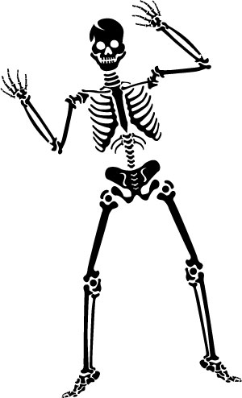
- Begin Researching Zombie or other creature-like Photoshop tutorials.
- Design a background to match your self-zombie portrait
Option B: Creepy Places
- Create a computer graphic of a creepy place or places
- Utilize Photoshop filters and styles to enhance the creepiness
- Download fonts and utilize type effects in your work
Option C: Halloween Postcard/Advertisement
- Create a postcard or advertisement for a Halloween function
  - Hayrides, house party, ghost walk, upcoming even
- Utilize text, filters, and styles to enhance your work
Option D: Halloween Movie Trailer Poster
- Using online high quality graphics to create a movie trailer poster
- Utilize text, filters, and styles to enhance your work

Step Two: Creating a New Project Folder
- Make a new folder in your Graphics P4 folder
- Remember to right click or Control /Left click to create
- Label this folder Halloween

Step Three: Sketch Three Possible Ideas for your Project

Step Four: Browse the Web for Photoshop Special Effects
- Search (by using Google) Photoshop special effect tutorials
- Bookmark Useful tutorials and refer back for future use.

Step Five: Search and Import Graphics
- Take digital photos using the green screen and digital camera
- Import the images you took into your project folder
- Search the Internet for HIGH RESOLUTION photos that you may want to use in your final project.
- Label each photo and organize into your project folder.
Instructor Signature:
_________________

-------------------------------------------------- STOP & SHOW YOUR INSTRUCTOR ----------------------------------------------
Step Six: Setup a new Adobe Photoshop document
- Start Adobe Photoshop and set up a new document
- Document Properties
  - 8.5 x 11 inches (width and height dimensions will vary on portrait vs landscape)
  - 300 Resolution
  - RGB Color Mode
- Save your newly created Adobe Photoshop document in you project folder as:
- _ _ (first & last initial) Halloween.PSD
- Import your images into Photoshop
- Label your image layers
- Stylize your text
- Made sure the overall poster/card/place/pic is visually appealing using the Principles & Elements of Design.

-------------------------------------------------- STOP & SHOW YOUR INSTRUCTOR ----------------------------------------------
Instructor Signature:
_________________
Step Seven: Flatten, Save and Print your Completed Poster
- Finalize any last minute changes by Saving
- Choose File → Save As and save a copy of your poster as _ _ (first & last initial) Halloween.JPEG
- Choose Layer → Flatten Image to merge all layers together and reduce file size.
- Choose Image → Color Mode→ CMYK
  - CMYK is our color mode specifically for printing
- Choose File → Print-select the 5550 color printer
  - Make sure you select the proper page layout option

--------------------------------------------------------------------- GRADING-------------------------------------------------------------------

File Folder Structure 0 1 2 3 4 5 _____/5
- Did you save and label your files correctly?
- Do you have all images and working Photoshop files in your project folder?

Photoshop Technical 0 2 4 6 8 10 _____/10
- Did you label all layers?
- Is your image correct size, resolution, and color mode?
- Did you flatten and convert to CMYK?

Creativity 0 2 4 6 8 10 12 14 16 18 20 _____/20
- Does your poster utilize the Principles & Elements of Design?
- Did you effectively use a variety of Photoshop tools in your graphic?
- Is it evident you researched online tutorials in your final graphic design?

Photoshop was the death of me!
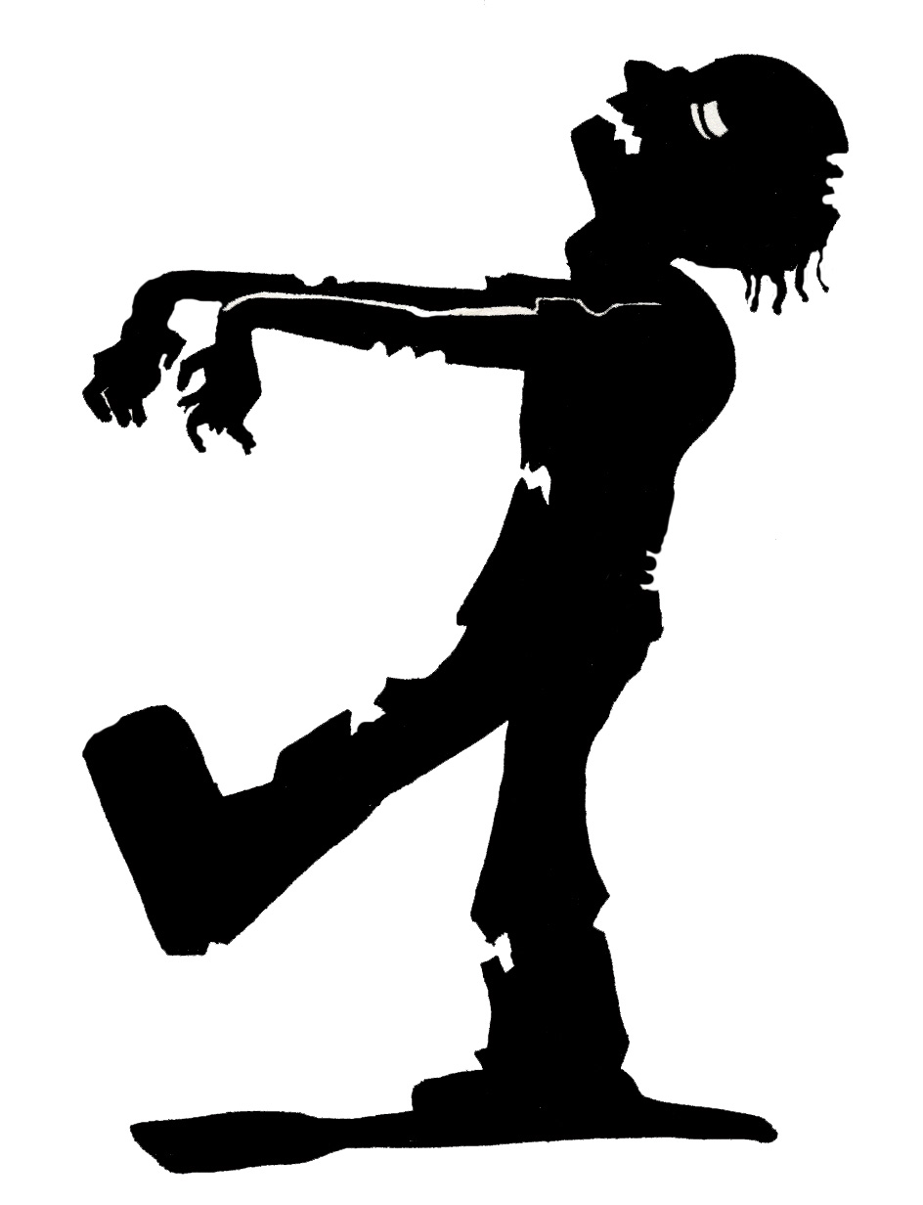
TOTAL: _____/35 x 2 = _____/70

