Name _________________________________ Date _______________

Math period ________ Unit 12 Review Packet/Frascatore

**Show all work! Remember to label each answer with appropriate units!!**

1) To the nearest cubic centimeter, find the **volume** of the given rectangular prism.

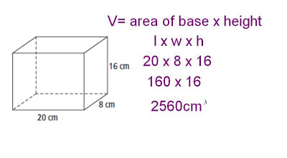

V = 

16.2 cm

8.1 cm

20.4 cm

2) A sphere has a radius of 6 feet. What is the exact **volume** of the sphere?

V = 

3) For Father’s Day, you take your dad to a golf course. At the fourth hole, a water cooler and disposable cone shaped cups are provided, as shown in the diagram. Find the **volume**, to the nearest tenth, of the water the cone shaped cup can hold.

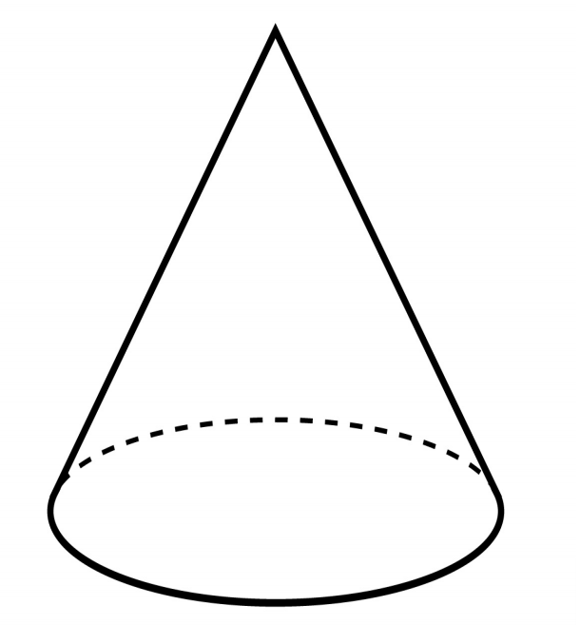

V = 

2 in.

5 in.

4) Find the **surface area** of the following isosceles triangular prism.

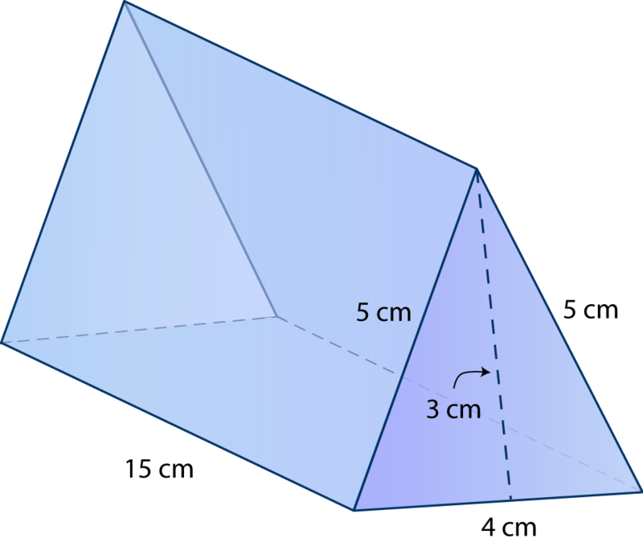

5) Find the **volume** of the cube. Express answer in simplest fraction form.

V = 

 m

6) Find the **surface area** of the following square pyramid.

10 cm

9 cm

7) You want to fill the cylinder shown below with water. All you have is a container shaped like a cone with a radius of 4 centimeters and a height of 6 centimeters. You can use this cone-shaped container to take water from a faucet and fill the cylinder.

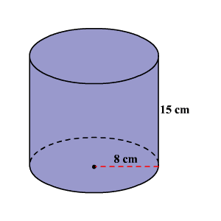**Part A**

Exactly how much water will fit in the cylinder?

V = 

**Part B**

Exactly how much water will fit in the cone?

V = 

**Part C**

Using your answers to parts A and B, determine how many full cones will fit in the cylinder ***without overflowing*** the cylinder. Explain, in words, your reasoning.

__________ full cones will fit in the cylinder, because _________________________

__________________________________________________________________

__________________________________________________________________