UNIT 2:
Atomic theory and structure:

Atomic models – (Don’t have to be 100% correct-although the idea is to have a model that explains all known observations – AND even predict future ones)

How do we know atoms exists?
Aristotle-infinite
Democritus-the atom (correct hypothesis)

The first evidence of atoms:

Law of conservation of mass:
The amount of mass in a closed system remains constant. – mass cannot be created or destroyed

Law of definite proportions:
The proportions by mass of the elements in a compound is always the same

example:
water if 18g of water is broken down into H and O you have 2g of H and 16g of O.

H:O ratio is 1:8 by mass

from 45g of water you’d have 5g of H and 40g of O.

H:O ratio is still 1:8

Law of multiple proportions:
When a pair of atoms forms more than one compound the masses of one element that combine with a fixed mass of the other element are simple (whole #) ratios

ex. if 1g of H is used to make water 8g of O would be consumed.
and
if 1g of H was used to make hydrogen peroxide 16g of O would be consumed

the O:O ratio from these two facts is
1:2 (a simple ratio)

This all leads to….

#1 Dalton’s model – of atomic theory: (1803)
the theory of atoms is an excellent model for explaining the three previous laws.

- All elements are composed of atoms, which are indivisible and indestructible particles.

- All atoms of the same element are exactly alike

- Atoms of different elements are different

- Compounds are formed by joining atoms of two or more elements in definite whole number ratios

5. Atoms remain whole and are only rearranged in chemical reactions.

Dalton’s Statements 1 and 2 were found to be not completely accurate. Why?

What 3 laws led to Dalton’s atomic model?

#2 J.J. Thompson’s model of the atom:
The Plum pudding model (raison bun)

From the cathode ray tube: Beam of electrons

+ High voltage -

He found that the beam contained tiny negative charged particles (discovered the electron)

The electrons (plums) are loosely bound in a positive mass (the pudding)

Rutherford’s Gold foil experiment and model of the atom:

He used radiation: this is how he determined what kind of radiation he was using

charged
+ plate beta
gamma
- plate alpha

lead box with a detection

radioactive source screen

The gold foil experiment:

99% of
the
alpha
A + Alpha particles
Emitter is Gold foil hit here!
placed in the box

A detection screen surrounds
The foil

Rutherford saw that it was unusual for high velocity particles to be ‘occasionally’ deflected
By a very thin piece of matter.

“It’s like firing bullets at a piece of paper and once and a while one comes back and hits you!”

J.J. Thompson’s model doesn’t work
Alpha’s would all rip through a few atoms

#3 Rutherford’s model:
1 atoms are mostly empty space
2 The mass of an atom is concentrated in the center (nucleus)
3 The nucleus is positive

Rutherford’s model explains the observations

Bohr’s Model and emission spectra: OBSERVATIONS

A prism can separate colors of light
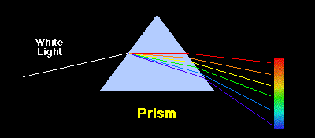
Separation of light by a prism according to wavelength

Continuous, emission, and absorption spectra

Origin of Emission and Absorption Spectra
are illustrated in the following figure.
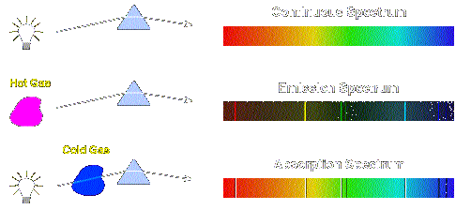
What causes the bright lines in an emission spectra?

*Physicist have determined that light comes in packets. Different colors of light are made up of different size’packets or Photons with specific energies.
E_{photon} = hf h-planck’s constant
f- frequency
E_{photon} = energy of a photon
Bohr sees that each element has its own spectra and all atoms of the same element have the same lines. Also elements with more electrons have more spectral lines

Hydrogen

Helium

Oxygen

Argon

Sodium

Krypton

Xenon

#4 Bohr’s Model:

- There are some orbits where electrons are in the lowest possible energy state called the ground state where the moving electrons don't emit energy.
- When electrons gain energy they go into excited states. Each element has specific orbits (or Energy levels) where the electrons can jump to. They can not exist in any other orbits and therefore can not gain or lose arbitrary amounts of energy.
- Each emission or absorption of radiation energy represents the electron transition from the one stationary orbit to the other.
- An electron is able to jump from any level to any other level. There is no way to predict which level an electron will jump down to if it is excited but it will eventually go back to the ground state

Bohr’ model explains emission spectra

Ground state

When electrons jump down energy levels they lose energy by releasing photons

Bohr’s model explains absorption spectra
Ground state

Incoming
light

When white light shines on the atom it absorbs the same colors that it emits because of the energy levels

The Quantum Model – aka (wave mechanical model) aka (electron cloud)

Developed by many physicists, and its weird, but it explained all observations in 50+ years of experiments.

*Electrons are waves and travel in orbitals
(These waves are special probability waves)

*An orbital is a region where the electron most likely exist (Or exist (99.99% of the time)

*Electrons can travel alone or in pairs
(2 electrons max in one orbital)

The mathematics behind these waves PERFECTLY fits the description of bohr’s spectral charts and MANY MANY other phenomena and experimentation.

You are expected to know the facts in this model but do not need to rationalize or explain it

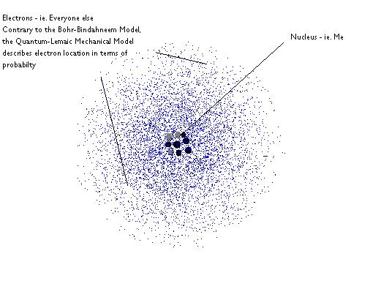

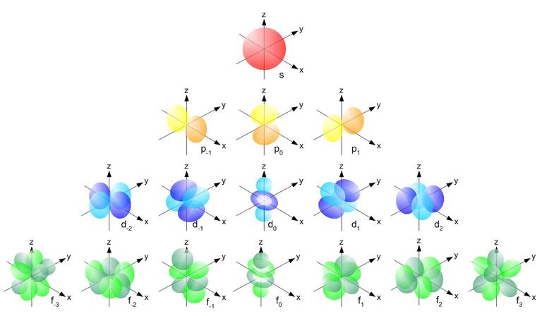

Atomic structure chart – fill in
 | Proton | neutron | Electron
Charge
Mass
location

 | Proton | neutron | Electron
Charge | +1 e.c. | 0 | -1 e.c.
Mass | ≈1 a.m.u. | ≈1 a.m.u. | ≈1/1800 a.m.u
location | nucleus | nucleus | orbitals
An a.m.u (or µ) is an atomic mass unit
Symbols from table: fill in from table O
Proton:
Neutron :
Electron: (aka beta minus particle)
Alpha Particle:

Proton: ${}_{1}^{1}p$
Neutron : ${}_{0}^{1}n$
Electron: ${}_{-1}^{0}e$
Alpha Particle: ${}_{2}^{4}{He}$
(a zero is used for an electrons mass since it is VERY small)
But remember its ≈ 1/1800 of an atomic mass unit

Which two have equal but opposite charge?
Which two have similar mass?
Approximately how much heavier is a proton (or neutron) than an electron?
Can you figure out what an Alpha Particle is made of?

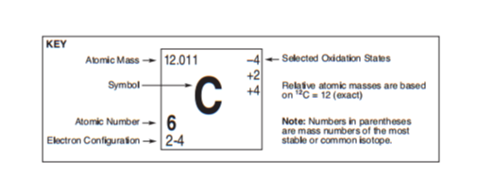

Atomic number – number of protons = the atom’s identity
Atomic mass – average mass of all naturally occurring isotopes. It is often close to the mass number of the most common isotope
Mass number = the # of protons and neutrons in an isotope (or nucleons)
Nucleon = anything in the nucleus (i.e. protons and neutrons)
Isotopes:
Same element different mass
Also means:
Same atomic number different mass number
Or
Same number of protons different number of neutrons
Examples:
C - 14
C – 13
C – 12
Can be written
${}_{6}^{14}C$ (6 protons and 8 neutrons)
${}_{6}^{13}C$ (6 protons and 7 neutrons)
${}_{6}^{12}C$ (6 protons and 6 neutrons)
More Examples
H – 1
H – 2
H – 3
${}_{1}^{1}H$ (nucleus same as a proton)
${}_{1}^{2}H$ (1 protons and 1 neutron)
${}_{1}^{3}H$ (1 protons and 2 neutrons)
NOTE: Neutral atoms have the same number of electrons and protons, OBVIOUSLY…

C – 12 – Used to define an Atomic mass unit (amu or u) –
Protons and Neutrons actually have different masses in different nuclei.
This is due to E=mc² (some of the nucleons mass is converted to energy in Binding a nucleus.)
One amu is defined as 1/12 the mass of Carbon 12.
So C-12 is the nucleus that weighs exactly a whole number, i.e., 12.0000000000000000000000000000000000000000…

Electron configurations: tell u where the electrons are
How many electrons does every NEUTRAL atom of Carbon have?
Principle energy level – general location of electrons in an atom.
Carbon in the ground state has electrons in the first 2 principle energy levels.
2 in the first
4 in the second
Its that simple…questions?
Each principle energy can be filled as followed
1st principle Energy level – 2 electrons max
2nd level – 8 max
3rd level – 18 max
4th level – 32 max (no need to memorize let’s look at Cs and Hf)

Valence electrons – These are the outer most electrons, the ones in the outer most principle energy level, and are responsible for MOST of an atoms behavior.
Kernel – all parts of the atom that are underneath the valence shell including the nucleus
How many Valence electrons are there in the following?
H
Li
Fr
Na
Comments / Observations????
Be
B
C
N
O
F
Ne
Comments / Observations????
He
Fe
Co
Mn
Comments / Observations????
See reference table for…
Excited states – the electrons are not found in the lowest energy states (Remember Bohr’s model?)
Easy to identify they don’t follow the correct order listed in the periodic table.
Example: Write a few excited states for Carbon
2-3-1
1 - 5
1 – 4 – 1 etc…

(still 6 electrons but 1 or more has jumped up)
(Note there is an infinite number of solutions – try to keep it simple)
It will be wrong if you put more electrons in a principle energy level than the maximums we discussed before!!!!!!
Example Neon:
2-7-1 is a possible excited state but 1-9 is WRONG!!!

Ions- Atoms that have become charged by losing or gaining electrons. (No chemical process can cause an atom to lose or gain protons)
Example: How many protons and electrons in
O⁻²
8p and 10e⁻
Na+
11 p and 10e⁻
Observations???
Question: what can you state about the quantity of the subatomic particles when an ion is positive?
Question: what can you state about the quantity of the subatomic particles when an ion is negative?
Since electrons are negative..

a positive ion has fewer electrons (lost electon(s))
And,
a negative ion has more electrons (gained electron(s))

Calculating average atomic mass:
Mass of isotope 1 x relative abundance
+ Mass of isotope 2 x relative abundance
___+___Etc……..__________________________
= Answer

Relative abundance is the percent
Remember for example 25% = .25

