Unit 3
Chapter 25 Nuclear Chemistry
(Chemistry of the nucleus - forget about electrons for a while)

Radiation – rays and particles given off by radioisotopes (Radioisotopes)

Radioisotope- radioactive isotope Have thousands of uses! (they can be natural or artificial)
Remember an isotope is the same element (same # of protons or atomic #), different mass (different # of neutrons or different mass #)
Radioisotopes produce radiation that means they are unstable!

Atoms are stable when they have close to a 1 to 1 ratio of neutrons and protons. (Really large nuclei are all unstable) (also means 2:1 mass #/atomic # ratio)
Anything with an atomic number higher than Pb has no stable isotopes.

Using radioisotopes:
Pro’s | Con’s
Can detect issues using ‘tracers’ | Can kill healthy cells
Can kill cancer cells | Can actually cause Cancer
Note: It is helpful to use isotopes with
short half lives,
and that are quickly eliminated from the body (Drink and pee a lot!)

KNOW THESE – MEMORIZE THESE!
4 Radioisotopes that may be found on the Regents Exam
Co – 60 Also used to treat cancer
C – 14 Used to date the age of organic materials (Shroud, Lewis and Clark’s campfire)
I – 131 Used to trace Thyroid disorders
U – 238 to lead (Pb-206) disintegration series is used to date rocks (earth)

Naturally occurring radiation types
see table o and write down ALL the symbols in your notes
Alpha- α ${}_{2}^{4}{He}$
Beta- β⁻ ${}_{-1}^{0}e$ or β⁺ ${}_{+1}^{0}e$
Gamma- γ ${}_{0}^{0}γ$ (high powered light)
The process of transforming an element into a different element is called transmutation.
When it happens naturally it is called natural transmutation
For Examples of natural transmutation see table n
All reactions must obey the law of conservation of charge and law of conservation of mass.
Conservation laws – basically means mass and charge can’t be created or destroyed
Applying the Concept: What goes in = what comes out
Mathematically means: left side = right side
In Science we write equations as a before and after….

before after
(The arrow is verbally stated yields)

Radium-226
²²⁶₈₈Ra ⁴₂He + ²²²₈₆Rn
“alpha decay”

Note: 226 = 4 + 222 (conservation of mass)
And: 88 = 2 + 86 (conservation of charge)

Potassium-42
“Beta minus decay”
Potassium-37
“beta postitve (positron) decay”

“Gamma decay”
⁹⁹Tc ⁹⁹Tc + γ

Recognizing reactions:
- all natural transmutations have one term on the left of the arrow
Artificial Transmutation When a nucleus is bombarded by particles in a lab. (Particle accelerators)
¹⁴₇N + ⁰₋₁e ¹⁴₆C
Target Bombarding with beta minus…
(electron capture)
Fission (is division) Splitting a larger nucleus into smaller ones (artificial)
¹₀n + ²³⁵₉₂U → ¹⁴¹₅₆Ba + ⁹²₃₆Kr + 3 ¹₀n + ENERGY
Fusion combining smaller nuclei into a larger one
Artificial in atomic bombs / natural on the sun (star)
³₁H + ²₁H ⁴₂He + ¹₀n + MORE ENERGY

Half life –
Is the amount of time
For ½ of any radioisotope to decay into another element
(Decay = Transmutate)
(you have been writing these reactions)
example:
²²⁶₈₈Ra ⁴₂He + ²²²₈₆Rn
(This is the decay of Ra into Rn)

See Table N:
Tip: find the number of half lives THEN use ‘common sense’ to multiply or divide.

Ways to determine half lives
# of half lives | Fraction of initial mass | % of initial mass | Example for  Mass remaining: initially 200. g in the sample | Calculating  Time elapsed | For example: if the half life is 2.20 days  Time elapsed:
0 | 1 | 100% | 200 | 0 | 0
1 | ½ | 50% | 100 | 1 x half life | 2.20 days
2 | ¼ | 25% | 50.0 | 2 x | 4.40
3 | 1/8 | 12.5% | 25.0 | 3 x | 6.60
4 | 1/16 | 6.25% | 12.5 | 4 x | 8.80
5 | 1/32 | 3.125 | 6.25 | 5 x | 11.0
6 | 1/64 | Etc… | 3.13 | 6 x | 13.2

 | Pro’s | Con’s
Fission | Produces millions of times more energy than chemical reactions | Produces radioactive wastes (isotopes) with long half lives (where do we store it?)
 | Requires no use of fossil fuels  (no air pollution) | Small possibility of melt downs / natural disasters
 | Safer than mining has historically been | Increases water temperature of nearby bodies.
Fusion | Produces even more energy than fission | Too high pressure and temperature to be contained
 | More readily available fuel (hydrogen isotopes) | “cold” fusion is too costly
 | Virtually no waste
Note: remember both nuclear fission and fusion convert a very very small amount of mass into energy according to E=mc². C = 300,000,000!

Penetrating power
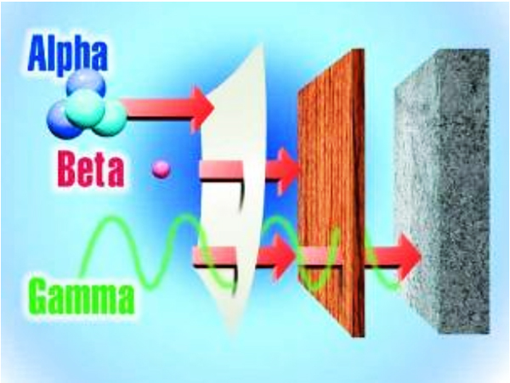
Pb
Smaller particles penetrate better
Alpha- α ${}_{2}^{4}{He}$ least penetrating
Beta- β⁻ ${}_{-1}^{0}e$
Gamma- γ ${}_{0}^{0}γ$ most penetrating

