Unit 6 Naming & moles

Naming simple substances: Using the stock system –

- Two element ionic compounds (Where the metal has only one oxidation state) – State name of metal “as is” state nonmetal adding “ide”

- Naming ionic compounds (Where the metal has multiple oxidation states) – State name of metal (followed by a roman numeral in parenthesis – The numeral equals the oxidation state) then state nonmetal adding “ide (OFTEN FORGOT!)

- Naming compounds with polyatomic ions - state polyatomic ions “as is” – if it ends with a nonmetal continue stating its name with an “ide”

NOTE: there a three polyatomic ions that end with “ide” try to remember these so you don’t think they are elements: mark them in your reference tables!
Cyanide
Peroxide &
Hydroxide
(Let’s do Examples in packet)
- . Covalent Compounds. (Prefix)These are formed from non-metals that share electrons. Because there are many sharing possibilities between two non-metals, the formula cannot be guessed unless we have a naming system that reveals the number of atoms involved.
For this we use a set of prefixes:

Prefix | Number of atoms
mono | 1
di | 2
tri | 3
tetra | 4
penta | 5
hexa | 6

We drop the prefix “mono” if the compound starts with a single atom.

Examples: CO = carbon monoxide
CO₂ = carbon dioxide

(note we don't say monocarbon monoxide
or monocarbon dioxide)

dinitrogen pentoxide = N₂O₅.
phosphorus trichloride PCl₃.

The Factor label method- A method of converting units or solving problems by paying attention to units.

Example 1: Jack C. wants to know how much gas he’ll need during his trip to spring break. Google Earth says his destination is 780 miles away. His V-W bus gets about 18 miles per gallon.

That's like saying 1 gallon = 18 miles

The answer will be in gallons so…..

780miles x 1gallon
18 miles

=780miles X gallon
18 miles
=43.3 gallons

Jack drives the first 190 miles in 3 hours. How fast was he driving on average?
In the U.S. speed is measured in m.p.h. or miles per hour which means (miles/hours)

190 miles/3 hours
=63.3 miles/hour

Factor label steps-

- Write the quantity to be converted with its unit(s)
(write "pers" like this example
7 miles per hour = $\frac{7 miles}{1 hr}$)

- You want the undesired units to be cancelled.

- Convert until you have the desired units.

- You can multiply by 1 without changing the physical quantity.

- All equalities over each other = 1

- These are all examples of one.
  - 1000 m /1 km
  - 24 hr. / 1 day
  - 60 min / 1 hour
  - 12 things /1 doz
  - 144things /1 gross
  - 2 blades / 1 pair of scissors
  - 1 ft = 12 inches
  - 1 mole of things = 6.02x10²³
  - 1 mole of Carbon atoms = 12 g

- This is not proportions!

Example: How many seconds is .5 min?
.5min X 60s/min = 30s

Ex: How many seconds is half an hour?

Ex: How many days is 3.15X10⁷ seconds?

Ex: What is your mass in kg? (1kg = 2.2lbs)

Ex: What is your height in cm? (1 in = 2.54 cm.)

Introduction to The Mole- The hub of chemistry

Atomic mass mass of elements or compounds as found on reference tables. (Pretty close to the number of protons + neutrons)
Finding the mass of Formulas – Formula mass
1. Look up the atomic mass of all the elements in the formula
2. Determine the # of each element
3. Add (or multiply) all the masses together
4. remember numbers outside of parenthesis multiply everything inside of them
This may be referred to as the atomic mass (measured in atomic mass units, u, amu)
It also may be referred to as the gram formula mass (measured in grams per mole) g/mole
Gram atomic mass- for simplicity…
A certain number of molecules of hydrogen was selected carefully so that its atomic mass = gram formula mass.
This number of atoms is called

Avogadro’s number or
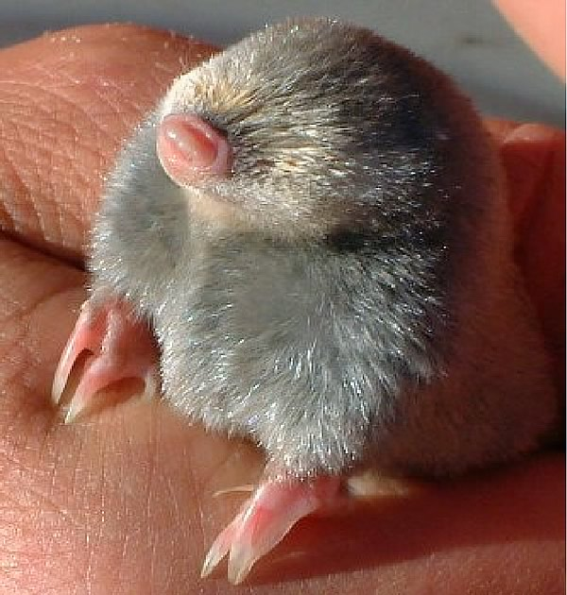
a mole,
which is 6.02X10²³.
or

602,000,000,000,000,000,000,000
This means one hydrogen atom has a mass of 1 u and one mole of hydrogen has a mass of 1g.
Likewise one Helium atom has a mass of 4u and one mole of Helium has a mass of 4g.
(four times greater than hydrogen.)
Lithium is 7 u and 7 g/mol etc….

Question: what’s the mass in grams of 6.02X10²³ atoms of carbon

12g

Q. what’s the mass in grams of .5 moles of Carbon?

6g

Q: What’s the gram formula mass of nitrogen?

14 g / mol

Q: what is the atomic mass of a nitrogen atom.

14 u

Q. What is the atomic mass of a nitrogen molecule?

28u (Remember is diatomic N₂)

Applying factor label to the mole
These values all equal one

1 mole = 1
6.02X10²³

1 mole of O =1
16g of O
http://www.eeweb.com/toolbox/calculator

*all masses from your table are the equivalence of 1mole

Problem: How many moles of F₂ is 6.02X10²¹ fluorine molecules?

P: How many moles of C is 60 grams of carbon?

P: How many atoms of sulfur are present in 64g of the substance?

P: What is the mass of a trillion atoms of lead?

1,000,000,000,000atoms

X 1 mole Pb X 207g of Pb
6.02X10²³ atoms 1 mole

=3.44 x 10⁻¹⁰ grams or .000 000 000 344g

Moles of compounds 1 step
- 1.00
- 0.300
- 0.247
- 1.7 x 10⁻²¹
- 1.7 x 10⁻²¹
- 2.0
- 0.5
- 20
- 0.09
- 0.17
- 85
- 261
- 11
- .28
- 0.0215

- 1.2 x 10²⁴
- 1.1 x 10²⁴
- 2.1 x 10²⁵
- 3 x 10²²
- 6 x 10²⁰
2 step problems
- 1.2 x 10²⁴
- 3 x 10²³
- 3 x 10²³
- 1.1 x 10²⁵
- 4 x 10²¹
- 70
- 32
- 130
- 6 x 10⁻²⁰
- 3 x 10⁻²³

Percent composition by mass

Percent = the part X 100%

The whole

Examples of percentages:

1) What’s a 17 out of 20 on a quiz?

The part correct is 17
The whole is 20

Percent = PART/WHOLE X100% = 17/20 X 100%
= 85%

2) A baseball player hits 296 balls and strikes out 690 times of the last 986 times she batted. What’s her batting average?

% = PART / WHOLE x 100%
= 296 hits / 986 swings X 100%
= 30.0%

3) What’s the percent by mass of hydrogen in water?

In H₂O there is one oxygen with a mass of 16 u. and two hydrogen’s with a mass of 1 u. each.

Part = 2
Whole = 16 + 1 + 1 = 18

Percent H = part / whole x 100%
= 2 u /18 u X 100%
= 11%

Check O should be 89% (WHY?!)

Percent O = 16 u / 18 u X 100% = 89%

Practice: find the % of each element in the following compounds:
1)CaS
2)PbI₂
3)NaMnO₄
4)Be(NO₃)₂
5)Mg(C₂H₃O₂)₂

Answers
1) Ca=56% S=44%
2) Pb=45% I=55%
3) Na=16% Mn=39% O=45%
4) Be=6.8% N=21% O=72.2%
5) Mg=17% C=34% H=4% O=45%

Lab Example:

Student determines that 2.2g of a substance is hydrogen and that 17.6g is oxygen. A) What percent of the compound is hydrogen and what percent is oxygen by mass?

Percent H is 2.2/19.8 X 100% = 11%

Check O should be 89%

Percent O is 17.6/19.8 X 100% = 89%

B) what is the empirical formula?
(just find moles of each)

2.2 g of H x 1 mole of H = 2.2 moles
1 gram of H

17.6g of O x 1mole of O = 1.1 moles
16 grams of O

(What is the mole to mole ratio?)

2.2 H to 1.1 O (simplified it 2 to 1)

Must be H₂O

Hydrated crystals- Salt crystals that have water bind within their crystal lattice. (Not all salts do this)

Anhydrous crystal- A salt crystal without water

Example problem:

- In an experiment 25 g of hydrated Copper Sulfate is ‘cooked’ to drive the water from it. Now its mass is only 15.8g. a) What percent of the hydrated crystal Is water?

Whole (hydrated salt)= 25 g
Part salt(anydrated salt) = 15.8g
25 - 15.8 = 9.2
Part water (heated away)= 9.2g

% = Part/whole x 100%
Percent water = 9.2g/25g X 100% = 37%

b) What is the hydrate’s formula?

CuSO₄ has a mass of 160u
H₂O has a mass of 18u

Find moles of CuSO₄

1 mole
15.8g x 160g = .09875 ≈ 0.1

Find moles of H₂O

1 mole
9.2g x 18 g = .5111 ≈ 0.5

1 CuSO₄ : 5 H₂O ratio

Answer: CuSO₄ • 5H₂O

Homework: Determine the percent composition of water and salt in the following compounds:
1) Na₂CO₃ • 10H₂O
2) CuSO₄ • 8H₂O
- CaCl₂ • 6H₂O

Answers:
- 63% water 37% salt
(106/286) (180/286)
- 47% water 53% salt
- 49% water 51% salt

This is the Mathematical stuff that led up to Dalton’s Theories!

Moles of gases:

Gas molecules are tiny! So they molecules occupy very little of the space of the gases total volume.

The volume is created by the fast moving gas molecules smacking each other around.
Avogadro's Hypothesis- ALL samples of gases under equal temperature and pressures take the same amount of volume regardless of their mass, size, polarity etc…
(assuming there are the same number of molecules)

At STP One mole of any gas occupies a volume of 22.4L!!!

! Factor label Conversion factor !
22.4L of any gas at STP = 1 mole

Q1. Hydrogen gas occupies 44.8 L at STP. How many moles of gas is this?
Q2. Xenon gas occupies 44.8 L at STP. How many moles of gas is this?
Q3. Hydrogen gas occupies 44.8 L at STP. How much mass does it have?
Q4. Xenon gas occupies 44.8 L at STP. How much mass does it have?
Q.5 5.0 moles of argon occupies how much space at STP?
Q.6 40 grams of He occupies how much space at STP?

Gas density: (reminder D=M/V)
At STP the mass of one mole of a gas is its gram formula mass and the volume is 22.4L.

Example: What’s the density of oxygen gas? (at STP) *remember Oxygen is O₂

D = m/v

Density= 32.0g (mass of 1 mole)
22.4L (volume of 1 mole)

D = 1.43 g/L

Empirical formula - is a formula that shows the simplest ratio of elements present in a compound.

Also Known As: simplest ratio

Note: salts (ionic compounds) are always empirical, since they are a continuous pattern and not molecular. A salt's empirical formula is called a unit cell.

Examples:
Glucose has a molecular formula of C₆H₁₂O₆. It contains 2 moles of hydrogen for every mole of carbon and oxygen.
The empirical formula for glucose is CH₂O.

Lab Example:

A student determines a compound consist of 1.2g C, .2g H, and 1.6 g Oxygen

Do Mole conversions:
1 mole
1.2 g x 12 g =

1 mole
0.2 g x 1 g =

1 mole
1.6 g x 16 g =

.1 moles C
.2 moles H
.1 moles O
Empirical Formula must be
CH₂O
*Note: the molecular formula C₆H₁₂O₆ cannot be determined from this mole conversion alone
Molecular formula = indicates the actual number of atoms in the molecule

