Photosynthesis and Respiration Test Review

- What is the carbohydrate synthesizing reaction called? What do you need for it to happen?
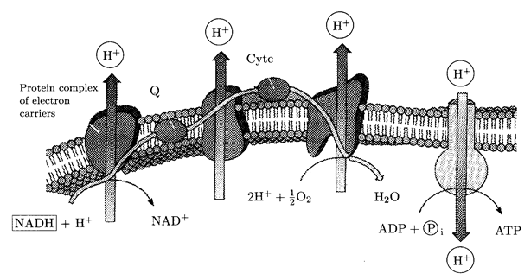
What is the above named? Where does it take place?

- What is the job of the proteins embedded in the ETC?
- In cell respiration what is the final electron acceptor?
- What is the process called that makes ATP through ATP synthase?
- What happens in the light dependent reactions and where does it occur?

- Where are the transport proteins located in respiration?

- What is oxidative phosphorylation?

- What is the difference between cyclic and non-cyclic photosynthesis?
.
- What makes the most NADH and FADH2 in cell respiration?
- What are the products of the light independent reactions?
- Where in the plant cell is chlorophyll found?

- For the citric acid cycle to go forward what is necessary?
- What is going on here?

- Its photosynthetic action spectrum is exactly complementary (opposite to) the action spectrum for green plants. What wavelengths of light does it have?
- What wavelength of light is absorbed in green plants?
- What is happening below? How does it show evolution?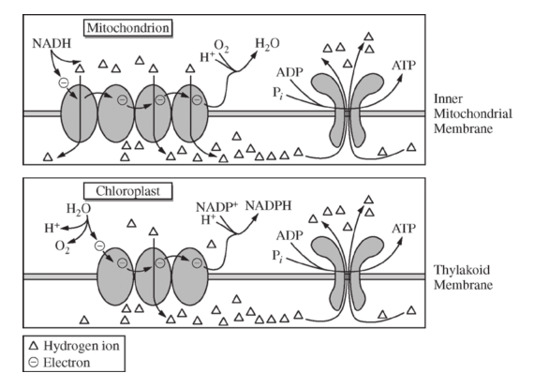

- During light dependent reaction what happens to water and where do its parts end up?

- What is ectothermic vs endothermic and which uses more ATP?

- What is an action potential and what is its job in terms of a neuron?
- Define fermentation. Is it efficient?

- Free Response

Know ETC in terms of photosynthesis.
How are electrons generated in photosynthesis?

Be able to read:
