Review for Mitosis and Meiosis
1. How do bacteria divide?

2. Define haploid and diploid. What do they mean in terms of chromosomes?

3. What are homologous chromosomes?

4. Mitosis produces identical cells because what does not happen?

5. Meiosis produces sex cells. When does mitosis occur with these cells?

6. What is part of the cell cycle? Define the stages.

7. DNA looks like what?

8. Most cells are found in what phase of the cell cycle?

9. What are spindles made of? What is the kinetochore?

10.What happens in anaphase?

11. How is mitosis different in animal cell vs a plant cell?

12. In order for the S phase to start(right before Mitosis) what molecules are necessary?

13. List 3 processes that create diversity for living organisms.

14. What part of meiosis reduces the chromosome number to haploid? Why does it happen?

15. When does crossing over occur?

16. Knowledge of the cell cycle has led to improved means of treating cancer. The drug 5-fluorouracil, which blocks the synthesis of thymine, inhibits the cell cycle at the end of what phase?

17. Define
a. fertilization
b. chromatids
c. centromere

18. What is this?
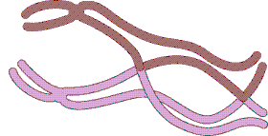
Know pictures of Mitosis. Explain both mitosis and meiosis.

