Biochemistry and Enzyme Test Review

- Why does ice float?

2. What does a pH of 7 mean?

3. What is the First Law of Thermodynamics?

4. How does bicarbonate/carbonic buffer help in the blood if the pH drops?

5. Differences among organisms are caused by?

6. What polymers are formed via dehydration synthesis?

7. Polysaccharides, triacylglycerides and proteins are similar how?

8. Describe the 4 structures of proteins and tell how they form.

9. How does heating affect macromolecular structures in aqueous solution?

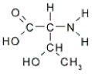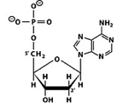

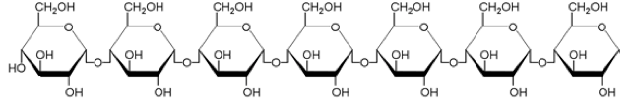
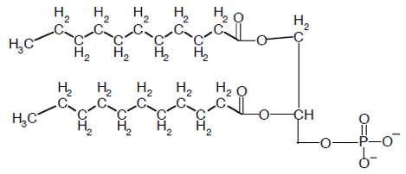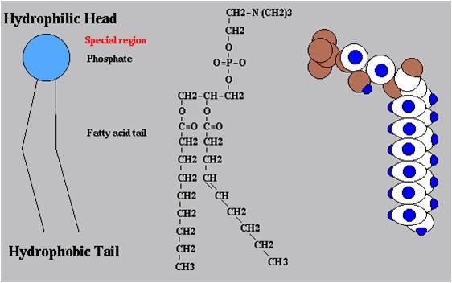
10. Identify the above.

11. Changing one amino acid in a protein does what?

12. Define
- Competitive inhibition
- Non-competitive inhibition
- Allosteric inhibition
- Cofactors

13. If a transport protein dissects a head of the phospholipid what property does the protein have?

14. X → Y → Z → A. What is happening here in terms of enzyme reaction?

What is X, Y, Z and A

15. 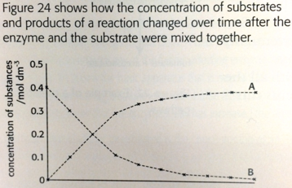
What is happening here?

16. Why do farmers spray water on crops to protect the plants from a freeze?

17. Explain how primary structure of a protein determines how it folds into 3D.

Practice Chi and scientific method.

Know the properties of water and the role they have in metabolism, the environment and in plants.

18. One R group is made of serine OH and another is made of alanine CH3. Where would you find the amino acid in a globular protein?

19. Normal hemoglobin is a tetramer, consisting of two molecules of β hemoglobin and two molecules of α hemoglobin. In sickle-cell disease, as a result of a single amino acid change, the mutant hemoglobin tetramers associate with each other and assemble into large fibers. Based on this information alone, we can conclude that sickle-cell hemoglobin exhibits what protein change?

20. How does sweating cool the body? What happens to H bonds?

21. When the number of amino acid differences between organisms is great are the organisms closely related? Why or why not?

22. Mutations that result in single amino acid substitutions in an enzyme may change what?

