Genetics Test Review

- Define DNA and explain its structure.
Deoxyribonucleic acid
Double helix
A-T,G-C
Deoxyribose
Complementary strand

- How does DNA send its recipe?
Single strand mRNA

- What is the Hershey Chase experiment? How did the experiment prove DNA was the main heritable substance?
In their experiments, Hershey and Chase showed that when bacteriophages, which are composed of DNA and protein, infect bacteria, their DNA enters the host bacterial cell, but most of their protein does not. Although the results were not conclusive, and Hershey and Chase were cautious in their interpretation, previous, contemporaneous, and subsequent discoveries all served to prove that DNA is the hereditary material.

- What is the Chargaff’s rule? A goes to T /G goes with B

- What happens in the S-phase? DNA is replicated

6. Label

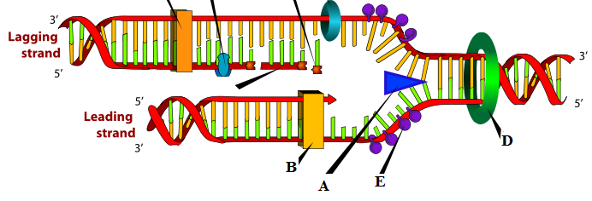
- Helicase D. topoisomerase

- RNA Polymerase E. SSB’s

7.
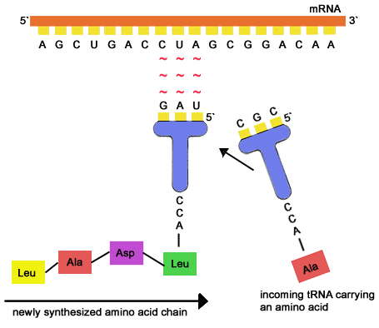
What is going on? tRNA is bringing in amino acids to make a functional polypeptide

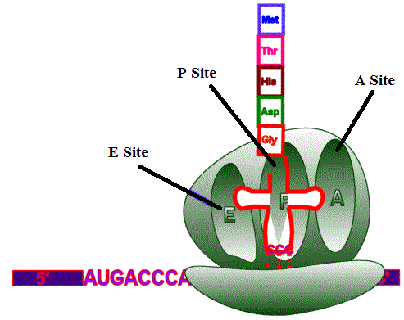
8. Explain translation using the pictures.
A site accepts the tRNA that matches the next codon; P site holds the amino acid chain that will bond with the amino acid in the A site; E site is where tRNA is released

9. Define
A. Gene Therapy= the transplantation of normal genes into cells in place of missing or defective ones in order to correct genetic disorders.

B. Selective Breeding= Selective breeding involves selecting parents that have characteristics of interest in the hope that their offspring inherit those desirable characteristics.

C. Cloning= replicate (a fragment of DNA placed in an organism) so that there is enough to analyze or use in protein production.

- Mutation= change in DNA, gives variation

10. What type of mutations are the most dangerous?
Deletion, insertion

11. What molecule makes protein complexes and it is produced in the S phase.

12. 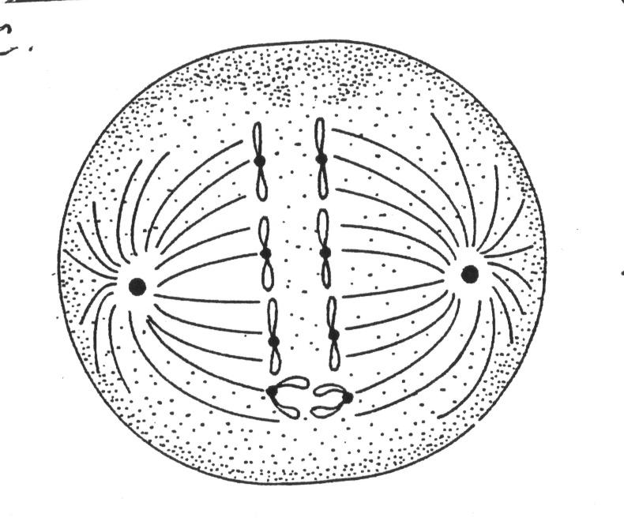What is happening here? Anaphase in Meiosis producing “n” or haploid

13. What happened in the Griffith experiment with mice? What did it show?
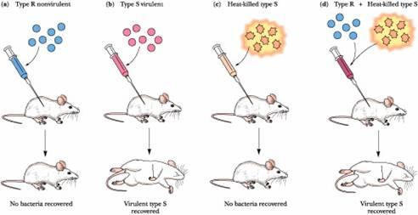
Bacteria is transformed.

14. Name 4 things that create genetic variation.
Mutations
Crossing over
Independent assortment
Sexual Reproduction

15. If the mother has blue eyes and the dad has brown eyes, what are the possible genotypes of their daughter?
Bb and bb

16. In terms of inheritance how is blood type defined? Is it Mendelian?
Codominant. It is not Mendelian

17. What is incomplete dominance? Give an example.
Not one allele is dominant so they blend their colors. Pink four o’clocks.
Red or white or Pink

18. What is the HOX gene? What is inactive X?
Hox is a developmental gene that affects all parts of development. For example turns on limb gene and limbs will appear.
Inactive X are Barr Bodies. The X becomes inactive in autosomal cells of woman.

19. Which of the following organisms contains a single promoter that controls and regulates a region containing a group of genes for a specific function? Prokaryotic or Bacteria

20. 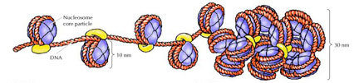
What is this?
Nucleosomes. These condensed parts of the DNA are not expressed because transcription proteins/factors have no access to their promoters.

21. What is this? What is the white?

What is the green? Inducible operon.The white objects are inducers and they induce a shape change in the green molecule,(repressor) causing it to release the operator and allowing RNA polymerase to bind the promoter and initiate trranscription.

22. 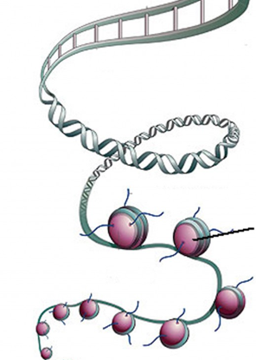 What are the red circles? Histones

23. Know how to transcribe DNA.

24. How do you know if a mutation is dangerous? Illness or death

25. 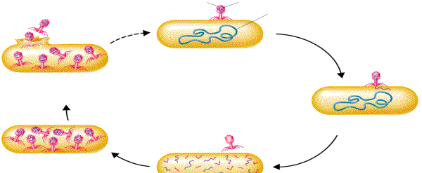

Explain this. Lytic cycle. As this occurs there will be more and more mutations.

26. How do viruses effect genetic variations? Viral genetic material integrates into the host genome creating a stable, heritable hybrid of genetic material

27. What type of cell signaling is this?
Voltage gated Ca²⁺ channels open, triggering an influx of Ca²⁺. This results in synaptic vesicles fusing with the membrane and releasing neurotransmitter into the synaptic cleft.

28. Before it receives the correct chemical signal, adenylate cyclase is an inactive enzyme. Once it becomes a functioning enzyme it will begin converting ATP into cAMP, by removing two phosphates. What would be the effect on the cell if there was a mutation causing the adenylate cyclase to stop converting ATP into cAMP?

The lack of the second messenger would limit signal amplification in the cell.

28. Define acetylation and methylation. Acetylation is unwinding of the gene so it can be transcribed
Methylation is staying wound up and gene is off.

29. What is going on?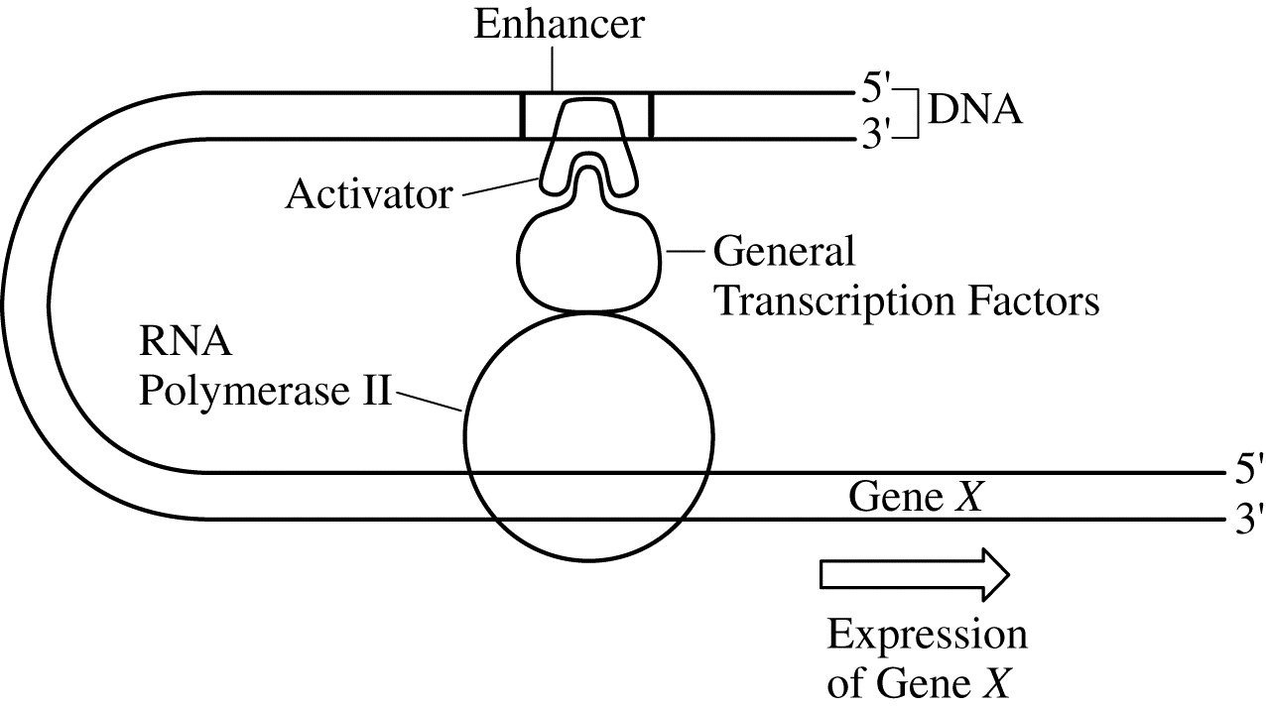
Eukaryotic gene regulation

30. Understand the transformation lab.

31. Discuss genetic engineering .

Transgenic= relating to or denoting an organism that contains genetic material into which DNA from an unrelated organism has been artificially introduced.

Electrophoresis= the movement of charged particles in a fluid or gel under the influence of an electric field.

PCR= olymerase chain reaction (PCR) is a technique used in molecular biology to amplify a single copy or a few copies of a segment of DNA across several orders of magnitude, generating thousands to millions of copies of a particular DNA sequence.

RFLP= a variation in the length of restriction fragments produced by a given restriction enzyme in a sample of DNA..

Gene therapy= the transplantation of normal genes into cells in place of missing or defective ones in order to correct genetic disorders.

32. The unit of genetic organization in all living organisms is the chromosome. Explain.

