Human Body Systems
Unit 1 Test Review
Define Tissues:

The four types of tissue, general function, and a location where each tissue is found:

- Epithelial/Sheets, skin, lining of organs and blood vessels=Secretions, diffusions

- Connective/ Matrix/ bones, blood, tendons, ligaments

- Muscle/Movement/ striations, nuclei, voluntary and involuntary/ produce heat

- Neuron/ communication

- Make sure you can recognize microscopic views of the tissue types.
Learning Log tomorrow

Distinguish between tendons and ligaments. To what class of tissue do they belong? Connective Lig=bone to bone
Tendon=bone to muscle

Name the 3 parts of the coxal bone.
- ______ilium__________________
- ___ischium_____________________
- ___pubis_____________________

Name my bones!

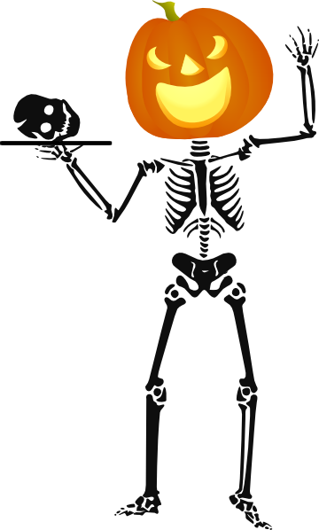

←

Bones in this region are called _____cervical_______________________

Bones in this region are called _______vertebrae_____________________

Tibia

Carpal

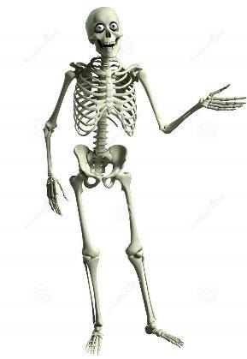

List functions of the skeletal system:
Support Protect Attach muscles and make blood

Describe how ribs are attached in the body using directional terms.
Ribs are attached to the anterior to the sternum and to the posterior to the thoracic vertebrae

Name bones that comprise the Axial Skeleton:

- 29 bones in the head - (8 cranial and 14 facial bones) and then also 7 accociated bones (6 auditory ossicles and the Hyoid Bone)
- 25 bones of the thorax - (the sternum and 24 ribs)
- 26 bones in the vertebral column (24 vertebrae, the sacrum and the coccyx)

Describe the bone types of the skull and their location using anatomical terms.
- ________________________________________________________________________________________
- ________________________________________________________________________________________
- ________________________________________________________________________________________
- ________________________________________________________________________________________

cephalic

____ Know your Regional and Anatomical Terms!

Here are some examples:
medial

occipital

____ 37. medial

____ 38. sacral

____ 39. cephalic

____ 40. lumbar

____ 41. olecranal

____ 42. inferior

____ 43. deep

____ 44. cervical

____ 45. thoracic
Name the three muscles built onto your Maniken and describe their function.
Temporalis, Orbicularis oculi muscle, Orbicularis oris muscle.

Describe the structure of DNA:
If you think of the double helix structure as a ladder, the phosphate and sugar molecules would be the sides, while the bases would be the rungs. The bases on one strand pair with the bases on another strand: adenine pairs with thymine, and guanine pairs with cytosine.

How is DNA coded?
A gene is an instruction written in the language of the DNAcode, which has four chemical letters (bases): A, C, T and G. Each A is always paired with a T, and each G always with a C. Scientists use a technique called DNA sequencing to reveal the order of these base pairs.

What nucleotide pairs are found in DNA? A:T and G:C

What comprises the ‘backbone’ of DNA?
backbone of alternating sugar and phosphate molecules known as the "sugar-phosphate backbone".

Describe the process of gel electrophoresis using the following words:
gel, wells, electrical current, charge, size, restriction enzyme

Gel electrophoresis is a method for separation and analysis of macromolecules (DNA, RNA and proteins) and their fragments, based on their size and charge. DNA is found at a scene and put through PCR to magnify the amount. Then, DNA is placed in a centrifuge with restrictions enzymes that cut up the DNA into small fragments. DNA is negative and is put into wells and electric current is sent through the gel which separates the DNA into fragments.

Describe biometrics and how it relates to identity.

Biometrics refers to metrics related to human characteristics. Biometrics authentication (or realistic authentication) is used in computer science as a form of identification and access control. It is also used to identify individuals in groups that are under surveillance.

