Human Body Systems
Unit 1 Test Review

Define Tissues:

The four types of tissue, general function, and a location where each tissue is found:

- ________________________________________ 3. ________________________________________

- ________________________________________ 4. ________________________________________
Make sure you can recognize microscopic views of the tissue types.

Distinguish between tendons and ligaments. To what class of tissue do they belong?

Name the 3 parts of the coxal bone.

- ________________________

Name my bones!
- ________________________
- ________________________

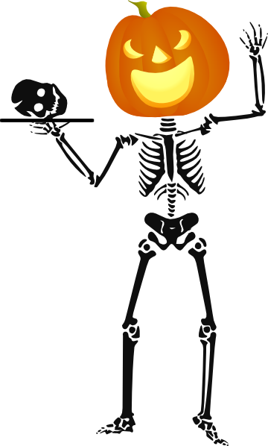

←

Bones in this region are called ____________________________

Bones in this region are called ____________________________

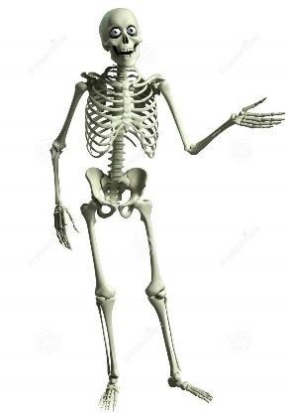

List functions of the skeletal system:

Describe how ribs are attached in the body using directional terms.

Name bones that comprise the Axial Skeleton:

Describe the bone types of the skull and their location using anatomical terms.
- ________________________________________________________________________________________
- ________________________________________________________________________________________
- ________________________________________________________________________________________
- ________________________________________________________________________________________

cephalic

____ Know your Regional and Anatomical Terms!

Here are some examples:
medial

occipital

____ 37. medial

____ 38. sacral

____ 39. cephalic

____ 40. lumbar

____ 41. olecranal

____ 42. inferior

____ 43. deep

____ 44. cervical

____ 45. thoracic
Name the three muscles built onto your Maniken and describe their function.

Describe the structure of DNA:

How is DNA coded?

What nucleotide pairs are found in DNA?

What comprises the ‘backbone’ of DNA?

Describe the process of gel electrophoresis using the following words:
gel, wells, electrical current, charge, size, restriction enzyme

Describe biometrics and how it relates to identity.

