Quiz Review

- Describe in detail the 4 tissues.

- Epithelial = Sheets, Secretions, absorptions, diffusion, protection, close together

B. Connective=Matrix, binding and support, bone, blood, ligaments, tendons

C. Muscle=Movement, heat, long cylinder cells

D. Neural=Communication, stimulus response, long processes

- Job of the skeletal system.
SPAM
Support, Protect, Attach, make blood

3. Axial vs Appendicular Skeleton

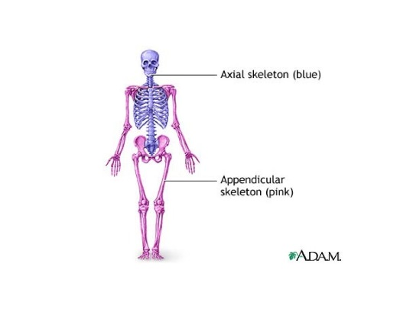

- The bone in the forearm that attaches to the thumb side of the wrist is the:
Radius

5. The most proximal bone of the leg would be the
femur

6. Which lower leg bone is found on the lateral side of the leg?
fibula

7. Which of the following groups of bones would make up the coxal bone of the pelvis?

ilium, ischium, and the pubis.

8. The suture that joins the frontal bone to the two parietal bones is the: CORONAL

9. In the anatomical position, which forearm bone is medial?
ulna

10. The anterior union of the pelvis is the:

Pubic symphysis

11. The ribs, except for the floating ribs, are attached on the anterior side of the body to the:
Sternum

12. how tissue can impact individual identity & describe one specific example.
Epithelial?
Connective?
Muscle?
Neural?

13. Know how to do math for height.

