By Jordyn Grady
A poem about bullying.
Bullies are mean
Create a stop
Depend on friends
Enjoy life without them
Frowning is so yesterday
Gas is a bully to air
How’s that example?
Is this what is happening to you???????????
Joked about
K-i-s-s-i-n-ged
Laughed at in a mean way
Moaning for happiness
Not happy
Open splotches needing joy
Praying for hope
Questioning for the cure
Realizing sorrow
Stop bullying with me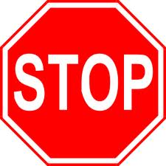
The cure is bravery
Use your voice
Varieties of bad things are in the world
Well this happens.
X-ray your heart.
You see sorrow.
Zebras are unique like you.

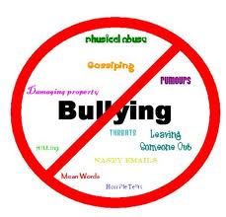

If it stops you will have a SMILE!!!!

