Math 7R – Spiral Review #20 DUE BY: June 8th
Pencil only!

%
Mrs. Frascatore
Number of Attempts: (3 max)
- 1st attempt ________
- 2nd attempt ________
3rd attempt (graded as is) _______

Name __________________________

Period ______ Date ____________

Directions: Show work on all problems, unless noted. Show work top to bottom, left to right. Calculators may be used, unless otherwise indicated. Attach additional sheets of work if needed. Label and BOX ANSWERS.
OVER
1. Solve the given equation and show check.  -2x – 4 = 8x – 24  Ck: | 2. Part A  Simplify the given expression.  4(3x – 7y) - 2x  Part B  Factor your simplified expression from Part A.  ________________________ | 3. Find the volume of the following rectangular prism.  V = Bh  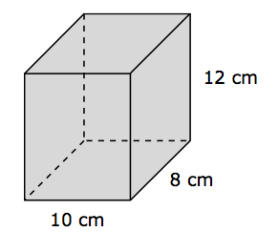
4. In the United States, 0.75% of people have Celiac Disease. If the population of the US is approximately 320,000,000 people, how many people have the disease? | 5. The cost of a gallon of gasoline, g, is marked up 15%. Write and then simplify an expression to represent the new cost. No work needed to be shown here.  Expression ________________  Simplest terms ____________  OVER  OVER | 6. Tom made a scale drawing of his rectangular living room. The scale used was 1 in. = 2 ft. Tom’s drawing was 4 in by 6 in. What is the area of Tom’s living room? [Area =  x w]  OVER
7. Find the surface area of the given rectangular prism.  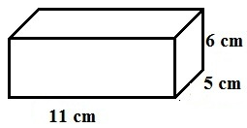 | 8. Borris saved $60.50 in 5 weeks. If he saved an equal amount each week, how much money would he save in 8 weeks? No calculators. | 9. The price of gasoline rises from $2.50 per gallon to $2.65 per gallon. What is the percent increase? No calcs.

10. Find the surface area of the square pyramid.

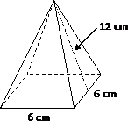
OVER

