**Unit 12**

**Surface Area & Volume**

**Homework Packet**

**12-1 – Surface Area of Rectangular Prisms and Cubes**

**12-2 – Surface Area of Triangular Prisms**

**12-3 – Surface Area of Square and Triangular Pyramids**

**12-4 – Volume of Rectangular Prisms and Cubes**

**12-5 – Volume of Triangular Prisms**

**12-6 – Volume of Square and Triangular Pyramids**

**12-7 – Volume of a Cylinder**

**12-8 – Volume of a Cone**

**12-9 – Volume of a Sphere**

**12-10 – Volume of a Hemisphere**

**Name ______________________________**

**Math 7 – Unit 12 (Surface Area & Volume)**

**HW #12-1 – Surface Area of Rectangular Prisms and Cubes**

**Mrs. Frascatore**

Name _______________________________ Period _________ Date _________________

**You may use a calculator on ALL questions, but be sure to show your work. Label your answers!**

1) Find the surface area of the rectangular prism.

13 in.

3 in.

9 in.

The surface area is ____________________.

2) Find the surface area of the cube. Express your answer in simplest mixed number form.

 in.

The surface area is ____________________.

3) Find the surface area of the cube.

4 ft

The surface area is ____________________.

4) A box has the shape of a rectangular prism as shown below. If the height is increased by 0.6 cm, by how much does the surface area of the box ***increase***?

10 cm

3 cm

5 cm

The surface area increases by ________________.

**Math 7 – Unit 12 (Surface Area & Volume)**

**HW #12-2 – Surface Area of Triangular Prisms**

**Mrs. Frascatore**

Name _______________________________ Period _________ Date _________________

**You may use a calculator on ALL questions, but be sure to show your work. Label your answers!**

1) A block of wood has the shape of a right triangular prism. What is its surface area?

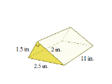

1.5 in.

2.5 in.

11 in.

2 in.

The surface area is ____________________.

2) Find the surface area of the following right triangular prism.

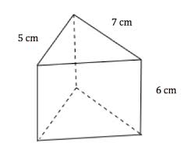

8 cm

The surface area is ____________________.

3) Find the surface area of the triangular prism. The base of the prism is an isosceles triangle.

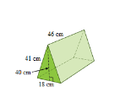

40 cm

41 cm

15 cm

45 cm

The surface area is ____________________.

4) Find the surface area of the following right triangular prism.

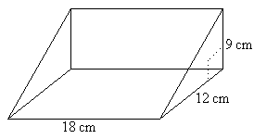

15 cm

The surface area is ____________________.

**Math 7 – Unit 12 (Surface Area & Volume)**

**HW #12-3 – Surface Area of Square and Triangular Pyramids**

**Mrs. Frascatore**

Name _______________________________ Period _________ Date _________________

**You may use a calculator on ALL questions, but be sure to show your work. Label your answers!**

1) Find the surface area of the square pyramid.

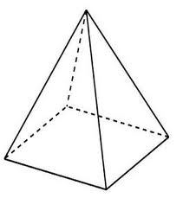

16 m

17 m

The surface area is ____________________.

2) A paperweight has the shape of an equilateral triangular pyramid. Find the surface area of the paperweight.

[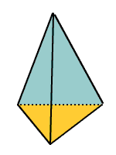](http://www.google.com/imgres?imgurl=http://www.kidport.com/reflib/Math/Geometry/images/Triangularpyramid.gif&imgrefurl=http://www.kidport.com/reflib/Math/Geometry/GeometryFaces.htm&h=200&w=150&tbnid=LIHJ9AHj2Ew92M:&zoom=1&q=triangular%20pyramid%20images&docid=47LXtK1VoH04LM&ei=IF89U_CKB6en0gG78IGADA&tbm=isch&ved=0CPMCEIQcMFw&iact=rc&dur=259&page=6&start=80&ndsp=16)

9 in.

5 in.

6 in.

The surface area of the paperweight is __________.

3) Find the surface area of the regular triangular pyramid.

[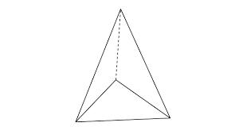](http://www.google.com/imgres?imgurl=http://i.stack.imgur.com/zUjqj.png&imgrefurl=http://blender.stackexchange.com/questions/5402/how-to-make-triangular-pyramids-on-each-face-of-an-original-triangular-pyramid&h=357&w=595&tbnid=DTYFucsg8xsxtM:&zoom=1&q=triangular%20pyramid%20images&docid=2h1IWRcfaajt8M&ei=IF89U_CKB6en0gG78IGADA&tbm=isch&ved=0CG0QhBwwCA&iact=rc&dur=413&page=1&start=0&ndsp=15)

4.5 in.

4.5 in.

5 in.

The surface area of the regular triangular pyramid is ____________________.

4) A student incorrectly says the surface area of the square pyramid is 868 cm2.

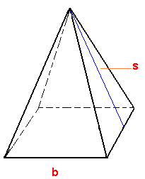

**Part A**

What is the correct surface area?

24 cm

25 cm

14 cm

**Part B**

What error did the student likely make?

______________________________________________________________

______________________________________________________________

**Math 7 – Unit 12 (Surface Area & Volume)**

**HW #12-4 – Volume of Rectangular Prisms and Cubes**

**Mrs. Frascatore**

Name _______________________________ Period _________ Date _________________

**You may use a calculator on ALL questions, but be sure to show your work. Label your answers!**

**Volume of a Prism**

V = Bh

1) Find the volume of the rectangular prism.

4 cm

4 cm

10 cm

The volume is ____________________.

2) Find the volume of the cube.

 cm

The volume is ____________________.

3) *How many times* larger is the volume of the 8 ft cube compared to the volume of the 4 ft cube. [You must find the volume of EACH cube first].

4 ft

8 ft

The volume of the 8 ft cube is __________ times larger than the volume of the 4 ft cube.

4) The volume of the rectangular prism shown below is 32.7375 ft3. What is its width?



The width of the volume is ____________________.

5) The rectangular prism below has dimensions 11.7 in x 4.5 in x 8.2 in. What is the volume?



The volume is ____________________.

**Challenge Questions**

6) Freezer A has interior dimensions of 1 ft x 1 ft x 5 ft and sells for $349.99. Freezer B has interior dimensions of 1.5 ft x 1.5 ft x 4 ft and sells for $699.99. Which freezer is a better buy in terms of *dollars per cubic foot*?

Freezer ________

7) Determine the volume of the three-dimensional figure below. Explain how you got your answer.



_____________________________________________________________________________

_____________________________________________________________________________

**Math 7 – Unit 12 (Surface Area & Volume)**

**HW #12-5 – Volume of Triangular Prisms**

**Mrs. Frascatore**

Name _______________________________ Period _________ Date _________________

**You may use a calculator on ALL questions, but be sure to show your work. Label your answers!**

**Volume of a Prism**

V = Bh

1) Find the volume of the triangular prism.

[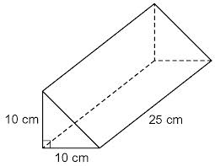](http://www.google.com/imgres?imgurl=http://chatt.hdsb.ca/~johnstonja/S0FA632C3.73/9132010_103829_13.gif?src%3D.gif?src%3D.PNG&imgrefurl=http://chatt.hdsb.ca/~johnstonja/?OpenItemURL%3DS0FA632C3&h=497&w=642&tbnid=rtX6YJSIbFataM:&zoom=1&q=triangular%20prism%20images&docid=MBbh3zLpY6SBhM&ei=Tbc6U6zfGYjI0QHMq4DYCQ&tbm=isch&ved=0CIIBEIQcMAo&iact=rc&dur=689&page=2&start=8&ndsp=16)

The volume is ____________________.

2) Find the volume of the triangular prism.

[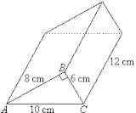](http://www.google.com/imgres?imgurl=http://www.mathsteacher.com.au/year10/ch14_measurement/23_prism/Image5480.gif&imgrefurl=http://www.mathsteacher.com.au/year10/ch14_measurement/23_prism/21prism.htm&h=167&w=201&tbnid=IGsrQV7zWBYMzM:&zoom=1&q=triangular%20prism%20images&docid=BqkTyakutYgIxM&ei=Tbc6U6zfGYjI0QHMq4DYCQ&tbm=isch&ved=0CMUBEIQcMB0&iact=rc&dur=440&page=3&start=24&ndsp=13)

The volume is ____________________.

3) Find the volume of the triangular prism.

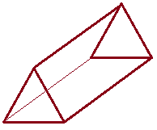

2.4 yd

7 yd

3.6 yd

The volume is ____________________.

**Challenge Question**

4) This section of a concrete skateboard ramp has the shape of a triangular prism.

**Part A**

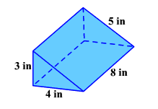Find the volume of the triangular prism.

6 ft

6 ft

9.2 ft

6 ft

The volume is ____________________.

**Part B**

A local skate park wants to create the same ramp as above. How much would the concrete cost if you pay $3.00 per cubic foot?

The cost of the concrete used in the ramp is $________________.

**Math 7 – Unit 12 (Surface Area & Volume)**

**HW #12-6 – Volume of Square and Triangular Pyramids**

**Mrs. Frascatore**

Name _______________________________ Period _________ Date _________________

**You may use a calculator on ALL questions, but be sure to show your work. Label your answers!**

**Volume of a Pyramid**

V = Bh

1) To the nearest cubic meter, find the volume of the square pyramid.



14 m

16 m

17 m

The volume is ___________________.

2) A paperweight has the shape of an equilateral triangular pyramid. Find the volume of the paperweight.

[](http://www.google.com/imgres?imgurl=http://www.kidport.com/reflib/Math/Geometry/images/Triangularpyramid.gif&imgrefurl=http://www.kidport.com/reflib/Math/Geometry/GeometryFaces.htm&h=200&w=150&tbnid=LIHJ9AHj2Ew92M:&zoom=1&q=triangular%20pyramid%20images&docid=47LXtK1VoH04LM&ei=IF89U_CKB6en0gG78IGADA&tbm=isch&ved=0CPMCEIQcMFw&iact=rc&dur=259&page=6&start=80&ndsp=16)

10 in.

5 in.

6 in.

The volume of the paperweight is ___________________.

3) A pyramid has a square base of side 4 in. and a height of 9 in. Find the volume of the square pyramid.

The volume of the square pyramid is ___________________.

4) Find the volume of the following triangular pyramid.

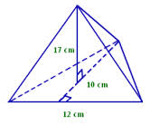

The volume of the triangular pyramid is ___________________.

**Math 7 – Unit 12 (Surface Area & Volume)**

**HW #12-7 – Volume of a Cylinder**

**Mrs. Frascatore**

Name _______________________________ Period _________ Date _________________

**Remember to show exact answers before rounding. You may use a calculator on ALL questions, but be sure to show your work. Label your answers!**

**Volume of a Cylinder**

V = πr2h

1) Use the diagram to help you find the *exact* volume of the right circular cylinder.



The exact volume of the right circular cylinder is ___________________.

2) Use the diagram to help you find the *exact* volume of the right circular cylinder.



1 ft

1 ft

The exact volume of the right circular cylinder is ___________________.

3) The circular cylinder has a radius of 2 cm, and a height of 5.3 cm. *To the nearest cubic centimeter*, find the volume.



The approximate volume of the right circular cylinder is ___________________.

4) The right cylinder below has a diameter of 12 inches and height of 25 inches. Use the diagram to help you, *to the nearest tenth*, find the volume.



The approximate volume of the right circular cylinder is _____________________.

5) Use the diagram to help you find the *exact* volume of the right circular cylinder.

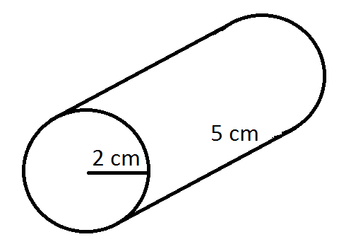

The exact volume of the right circular cylinder is _______________.

**Math 7 – Unit 12 (Surface Area & Volume)**

**HW #12-8 – Volume of a Cone**

**Mrs. Frascatore**

Name _______________________________ Period _________ Date _________________

**Remember to show exact answers before any rounding. You may use a calculator on ALL questions, but be sure to show your work. Label your answers!**

**Volume of a Cone**

V = πr2h

1) Use the diagram to find the *exact* volume of the right circular cone.



The exact volume of the right circular cone is __________________.

2) Use the diagram to find the approximate volume of the right circular cone, *to the nearest tenth*.



The approximate volume of the right circular cone is _____________________.

3) Use the diagram to find the volume of the right circular cone *to the nearest cubic meter*.



The approximate volume of the right circular cone is __________________.

4) The cylinder below has a height of 6 cm, and a radius of 4 cm. The right circular cone has a height of 8 cm, and a radius of 6 cm. Use the diagram below to determine *which has the greater volume*, the cylinder or the cone.



**Volume of a Cylinder**

V = πr2h

The exact volume of the right circular cylinder is __________________.

The exact volume of the right circular cone is __________________.

The ____________________ has the greater volume.

5) You want to fill the cylinder shown below with water. All you have is a container shaped like a cone with a radius of 4 inches and a height of 3 inches; you can use this cone-shaped container to take water from a faucet and fill the cylinder.

**Part A**

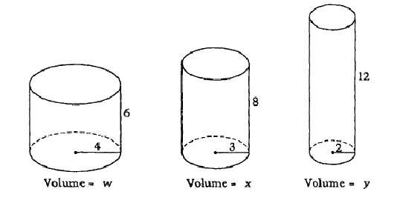 Exactly how much water will fit in the cylinder?

in.

in.

**Part B**

Exactly how much water will fit in the cone?

**Part C**

Using your answers to parts A and B, determine how many full cones will fit in the cylinder ***without overflowing*** the cylinder. Explain, in words, your reasoning.

__________ full cones will fit in the cylinder, because ______________________

__________________________________________________________________

__________________________________________________________________.

**Math 7 – Unit 12 (Surface Area & Volume)**

**HW #12-9 – Volume of a Sphere**

**Mrs. Frascatore**

Name _______________________________ Period _________ Date _________________

**You may use a calculator on ALL questions, but be sure to show your work. Label your answers!**

**Volume of a Sphere**

V = πr3

1) Use the diagram to find the *exact* volume of the sphere.



The exact volume of the sphere is ___________________.

2) Use the diagram to find the *exact* volume of the sphere.



The exact volume of the sphere is ___________________.

3) A cylinder has a radius of 3 inches and a height of 4¾ inches. A sphere has a radius of 3 inches. What is the *difference* between the volumes, to the nearest tenth of a cubic inch, of the cylinder and the sphere? (Remember to show BOTH volumes). **HINT:** Find the EXACT difference of the figures, then find the rounded difference.

**Volume of a Cylinder**

V = πr2h

(A) 21.2

(B) 51.8

(C) 68.3

(D) 96.6

4) The average basketball has a diameter of 9.5 inches. *To the nearest tent*h of a cubic inch, find the volume of an average basketball.

The approximate volume of the average basketball is _________________________.

5) Use the diagram to answer the following questions.

**Volume of a Cone**

V = πr2h



2.8 mm

a) Predict which of the figures shown above has the greater volume. Explain, in words, your reasoning.

____________________________________________________________________________

_____________________________________________________________________________

b) Use the diagram to find the exact volume of the cone.

c) Use the diagram to find the exact volume of the sphere.

d) Which shape, the cone or the sphere has the greatest volume?

***ONE MORE QUESTION 🡪 : )***

6) A cylinder has a diameter of 20 centimeters and a height of 20 centimeters. What is the exact volume of the largest sphere that will fit into the cylinder?

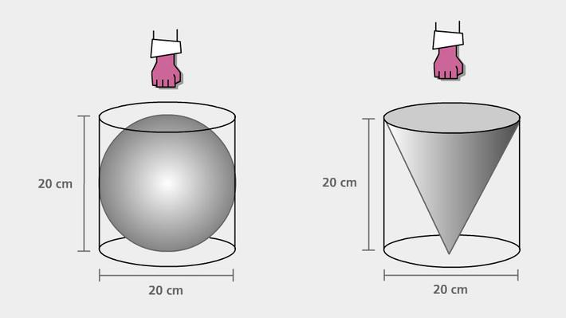

**Math 7 – Unit 12 (Surface Area & Volume)**

**HW #12-10 – Volume of a Hemisphere**

**Mrs. Frascatore**

Name _______________________________ Period _________ Date _________________

**You may use a calculator on ALL questions, but be sure to show your work. Label your answers!**

**Volume of a Sphere**

V = πr3

1) Use the diagram to find the *exact* volume of the *hemisphere*.

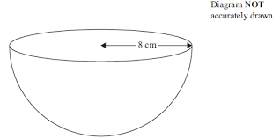

The exact volume of the hemisphere is ____________________.

2) Use the diagram to find the volume of the hemisphere, *to the nearest cubic centimeter*.

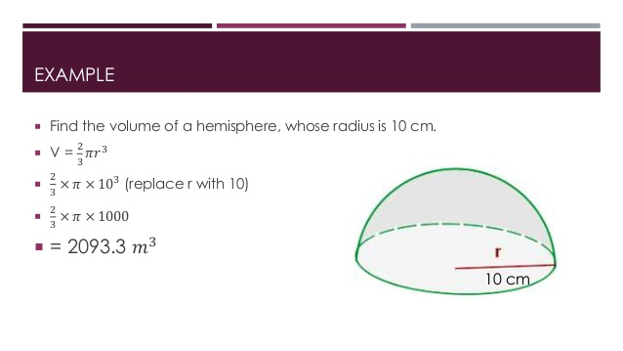

The approximate volume of the hemisphere is ___________________.

3) Use the diagram to find the exact volume of the hemisphere.

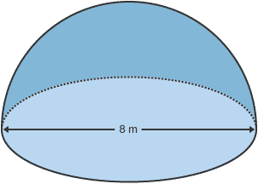

The exact volume of the hemisphere is ____________________.

4) Find the exact volume of the following three-dimensional object.

**Volume of a Cylinder**

V = πr2h

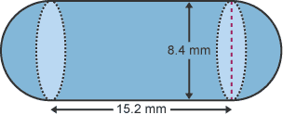

The exact volume of the three-dimensional shape is ____________________.

5) Find the exact volume of the following three-dimensional object.

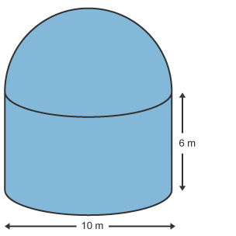

The exact volume of the three-dimensional shape is ___________________.

6) Find the exact volume of the following three-dimensional object.

**Volume of a Cone**

V = πr2h

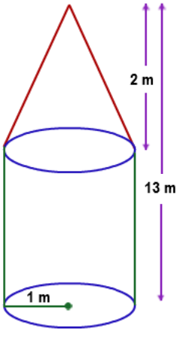

The exact volume of the three-dimensional shape is ______________________.