Photosynthesis and Respiration Test Review

What is the carbohydrate synthesizing reaction called? What do you need for it to happen?
PHOTOSYNTHESIS calvin cycle/ Products of the light reaction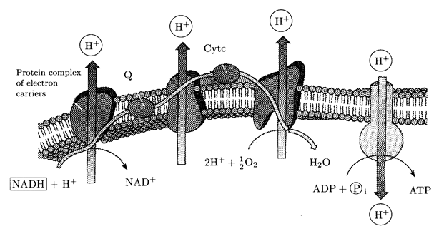
What is the above called? Where does it take place?
ETC CELL RESPIRATION inner membrane inside matrix

What is the job of the proteins embedded in the ETC?
HYDROGEN IONS ARE STRIPPED AND PASS THROUGH
In cell respiration what is the final electron acceptor?
OXYGEN
What is the process called that makes ATP through ATP synthase?
CHEMIOSMOSIS
What happens in the light dependent reactions and where does it occur?
ATP AND NADP IS FORMED. HAPPENS IN THE THYLAKOIDS OF THE CHLOROPLASTS
Where are the transport proteins located in respiration?
cristae
What is oxidative phosphorylation?
Last part of cell respiration when all of the ATP is produced.
What is the difference between cyclic and non-cyclic photosynthesis?
. In non-cyclic Photosystem, ATP, NADPH and oxygen are produced; in cyclic PSN, NADPH and oxygen are NOT produced, only ATP is produced.

What makes the most NADH and FADH2 in cell respiration?
Krebs cycel
What are the products of the light independent reactions?
Glucose ADP and NADP+
Where in the plant cell is chlorophyll found?
thylakoid
For the citric acid cycle to go forward what is necessary?
Acetyl coA
What is going on here?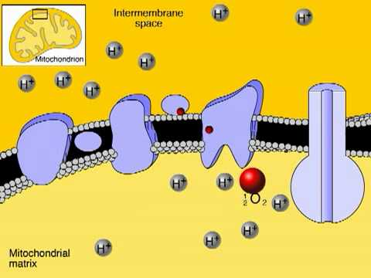
Do electron transport chains create a gradient so that ATP synthase can generate ATP molecules

Its photosynthetic action spectrum is exactly complementary (opposite to) the action spectrum for green plants. What wavelengths of light does it have? Green and yellow
What wavelength of light is absorbed in green plants? ROY BIV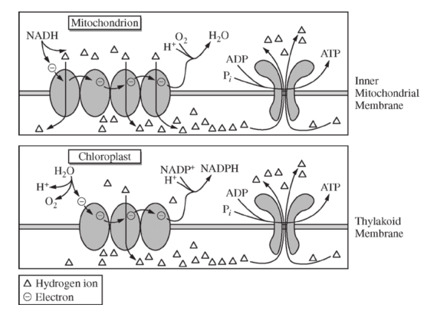

What is happening above? ETC create a gradient so that ATP synthase can make ATP. Both Respiration and photosynthesis carry this out.
During light dependent reaction what happens to water and where do its parts end up?
Water is split and H+ create ATP
What is ectothermic vs endothermic and which uses more ATP?
Ecto=cold blooded
Endo warm blooded
What is an action potential and what is its job in terms of a neuron?
an action potential is a short-lasting event in which the electrical membrane potential of a cell rapidly rises and falls, following a consistent trajectory.
Define fermentation. Is it efficient?
Yeast creates alcohol and carbon dioxide and 4 ATP’s not efficient. Muscle cells produce lactic acid and 4 ATP’s not efficient.
What is cell signaling?
reception, transduction and response

Free Response

Know ETC in terms of photosynthesis.
How are electrons generated in photosynthesis?
Know the stages in cell respiration.
How does glycolysis show evolution?
