AP Biology Midterm Review

A typical pedigree for a family that carries neurofibromatosis is shown below. Note that carriers are not indicated with half-colored shapes in this chart. Use the letter "N" to indicate the dominant neurofibromatosis allele, and the letter "n" for the normal allele.

1.
a. Is individual #1 most likely homozygous dominant or heterozygous? Explain how you can tell.
b. . What is the genotype of individual #3?

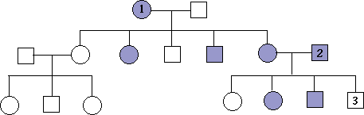

2. Why is surface area to volume ratio imporatant in a cell?

3. How do you find solute potential of a solution?

4. What does the table look like to find chi analysis?

If chi is greater than the probability value what does that mean?
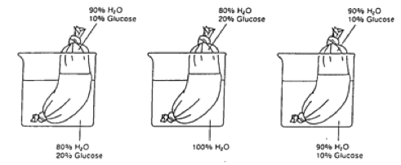

5.

What is happening in each of these bags in terms of water movement?

6. For exocytosis of a new protein to occur in a cell list the order of cell organelles that is travels through.

7. Define a mutation and how they effect metabolism in a cell.

8. What is this a picture of?
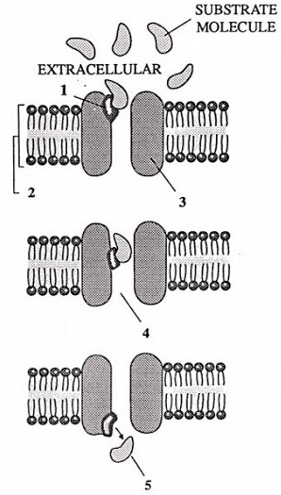

9. How does medication interfere with cell signaling?

10. Define
a. Diffusion

b. Facilitated diffusion

c. Exocytosis

d. Endocytosis

10. How do pigs have receptors for both human influenza and avian flu and what can occur because of this?

11. Define
a. Competitive inhibition

b, Noncompetitive inhibition

c. Allosteric inhibition

12. What is the formula for photosynthesis?

13. What happens in the light reactions of photosynthesis?

14. Calvin cycle?

15. What is a respirometer?

16. How would temperature affect a respirometer?

17. What is MPF? How does it effect the cell cycle?

18. How does pH affect enzymes? Why?

19. The negative rate of carbon dioxide absorption at very low light intensities is created by?

20. Name 4 properties of water and how they help in biology.

21. What creates Tay Sachs?

22. How does testosterone enter only specific cells?

23. Name the enzymes involved in DNA replication and their jobs.

24. Both energy and biomass numbers in an ecosystem for a pyramid. Why?

25. What happened in the Avery, MacLeod and McCarty’s experiment?

26. The human genome shares similar sequences with other living things that do not code for proteins. What hypothesis supports that?

27. Practice Grid ins.

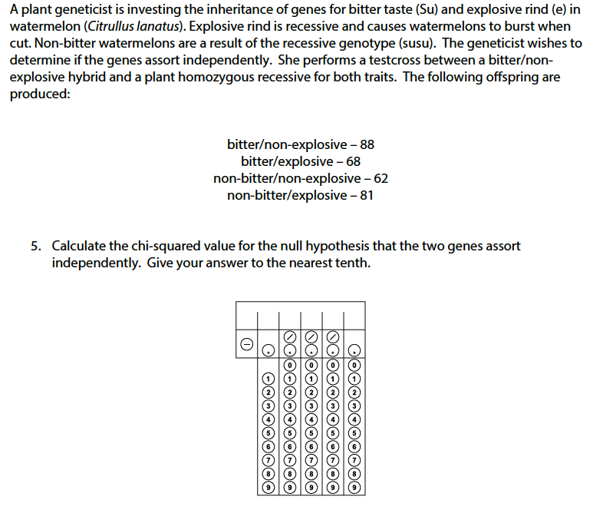

28. How are proteins modified after transcription and before translation?

29 Compare prokaryotic protein synthesis and eukaryotic protein synthesis.

30. Describe the effect of mutations on phenotypes.

31. What creates variation?

