Cell, Cell Transport, Cell Signal and beginning of cell respiration Test Review

- Why are cells SA/Volume ratio so important in terms of their job?

2. What is the endomembrane system? Explain.

3. What molecules can pass through a cell membrane? Why? What cannot? Why?

4. Define
- Isotonic
- Hypertonic
- Hypotonic

5. What is osmoregulation? Give an example of an animal using it.

6. What is a proton pump and who uses it?

7. How are cell membranes the same and how are they different?

8. Know water potential and how it works.

9. Tell what the following organelles do:
- Lysosomes
- ribosomes
- RER
- Nucleolus
- Mitochondria

10. 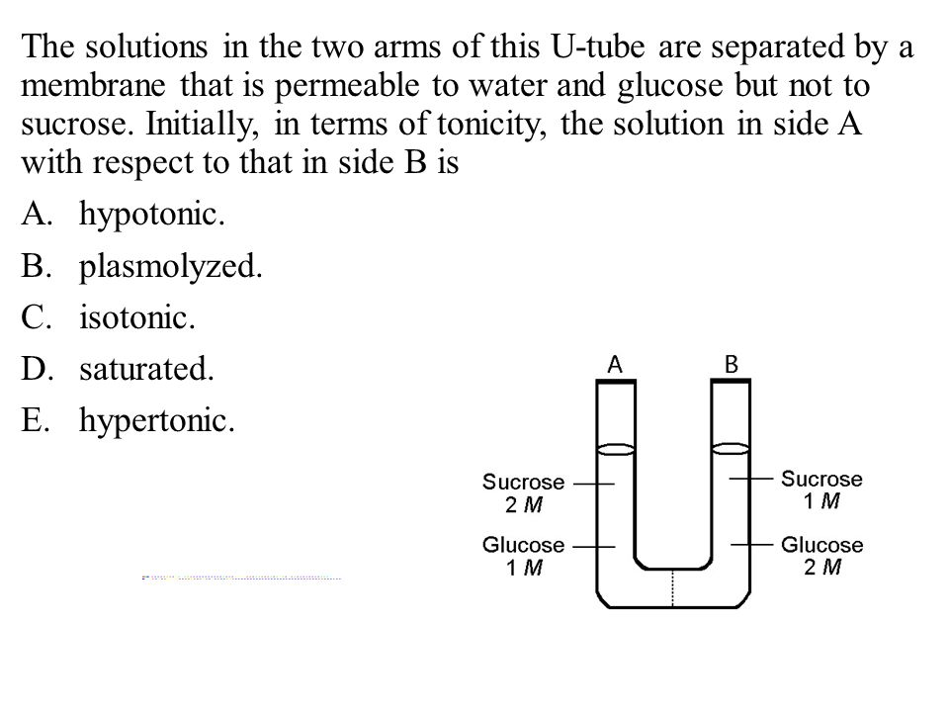

11. What is cystic fibrosis and how does it affect chloride channels?

12. Explain
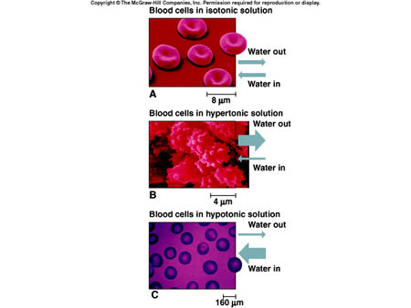

13. How do pharmaceuticals interfere with normal pathway signals?

14. Define intracellular receptors vs extracellular receptors. Explain.

15. In a retrovirus which uses RNA as genetic material where does all the variation come from?

16. How do neurons communicate?

17. Draw the formula for fermentation.

18. What happens in glycolysis?

19. Define oxidation and reduction?

20. How do find standard deviation and standard error?

Know and review your cell signal disease/drug/condition.

Review your notes. You can use your notes!

