Name: ____________________________________________ Date: ___________________________ Period: _____

Unit 2 Part 3 Notes– Macromolecules

- What are the macromolecules, and why is carbon such an important part of the macromolecules?
- Macromolecules (carbohydrates, lipids, proteins, and nucleic acids) are large molecules found in our cells. They are also called “organic molecules” because they contain the element carbon in large quantities. All macromolecules also contain the elements hydrogen and oxygen. Some macromolecules contain the elements nitrogen, phosphorus, and sulfur. Together, these are the six elements most commonly found in living organisms. You can remember them with the acronym CHNOPS.
- Carbon is tetravalent, meaning it has four valence electrons, so it can make four single covalent bonds to satisfy its outer electron shell (when filled, this shell contains eight electrons) or it can also participate in double bonds or triple bonds.
- Because carbon can make bonds with four other atoms at a time, it makes an excellent “backbone” for large molecules.

B. What are the common “groups” of atoms found in macromolecules?
- Certain groups of atoms tend to be found frequently in the various macromolecules. Due to the interactions between the different atoms in these groups, each of the groups gives certain properties or functions to the molecule of which it is a part. For this reason, the groups are called “functional groups.” See a chart of the functional groups below.

Name of Functional Group | Chemical Symbol of Functional Group | Molecules with this functional group can be called… | Macromolecules Containing this Functional Group | Properties that this functional group gives to the molecule of which it is a part
Hydroxyl | -OH | Alcohols  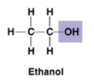 | Carbohydrates  Lipids  Proteins  Nucleic Acids | -Polar (as a result of the electrons spending more time near the more electronegative oxygen atom). This makes the oxygen slightly negative and the hydrogen slightly positive.  -Can form hydrogen bonds with water molecules  -Helps dissolve molecules such as sugars
Carbonyl | -C=O | Ketones (middle)  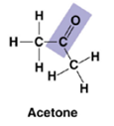  Aldehydes (end)  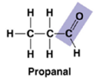 | Lipids  Proteins | -A ketone and aldehyde may be structural isomers (same chemical formula, different connections between atoms) with different properties  -Polar
Carboxyl | 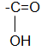  (sometimes written as –COOH) | Carboxylic Acids  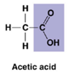 | Proteins  Lipids (fatty acid) | -Acts as an acid (can donate an H+ because the covalent bond between oxygen and hydrogen is so polar that oxygen may occasionally steal an electron from hydrogen, and H+ separates from the molecule) 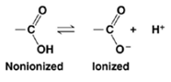
Amino | -NH₂ | Amines  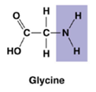 | Proteins  Nucleic Acids | -Acts as a base; can pick up an H+ from the surrounding solution (water, in living organisms)  -Can form Hydrogen Bonds  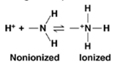
Sulfhydryl | -SH | Thiols  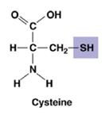 | Some proteins | -Two sulfhydryl groups can react, forming a covalent bond. This “cross-linking” between sulfhydryl groups helps stabilize protein structure and can be referred to as a disulfide bridge.
Methyl | -CH₃ | Methylated compounds  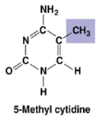 | Carbohydrates  Lipids  Proteins  Nucleic Acids | -Nonpolar (because the bonds between C and H are nonpolar covalent bonds)  -Often affects the expression of genes
Phosphate | -PO₄²⁻ | Organic phosphates  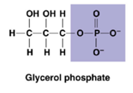 | Nucleic Acids  Phospholipids | -Contributes negative charge to the molecule of which it is a part.

- The configuration of the functional groups determines the properties of a molecule. For example, the addition of a hydroxyl group to a carbon skeleton turns that molecule into an alcohol. When an –OH replaces one of the hydrogens in ethane, a 2-carbon hydrocarbon, it becomes ethanol. Whereas ethane, like other hydrocarbons is hydrophobic, ethanol is hydrophilic because the –OH functional groups makes the otherwise nonpolar carbon skeleton polar.
- A small difference between the functional groups of molecules results in those molecules having very different functions. For example, the human steroid hormones (a type of lipid) differ only in the functional groups attached to a common carbon skeleton of four fused rings. A difference in structure results in a difference in function. (Testosterone causes male primary and secondary sex characteristics, and estrogen causes female primary and secondary sex characteristics.)
Note: Estradiol is another term for estrogen.

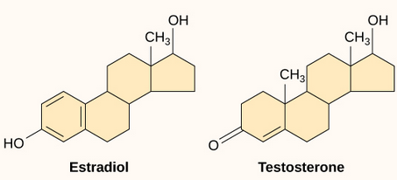

C. How are the four types of macromolecules formed and broken apart?
- The four macromolecules exist in two forms—monomers and polymers.
- Keep in mind that throughout this macromolecules section, that structure and function are always related to one another. If you change the structure, you change the function. This applies to all of the macromolecules.
- Monomers are the simplest unit of a macromolecule.
- Polymers are chains of monomers linked together.
- The process of adding monomers together to build a polymer is called dehydration, dehydration synthesis, condensation reaction, etc.
- In this process, an -H is removed from one monomer and an –OH is removed from another monomer (together forming H₂0), and a bond between the two monomers is left in their place. In other words, a polymer is being built (synthesis) from monomers, and water is lost (dehydration).
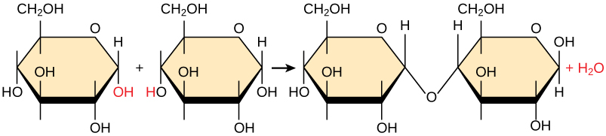

- The process of breaking a polymer down into monomers is called hydrolysis.
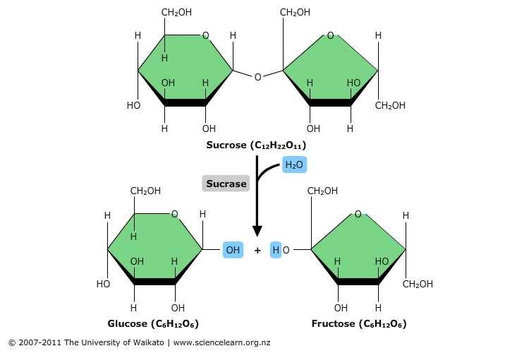
- In this process, water is added to break the bonds between the monomers. One monomer receives an –H, and the other receives an –OH. In other words, a polymer is being broken (lysis) into monomers, and water is added (hydro).

D. What are the properties of carbohydrates?
- Elements – The elements found in carbohydrates are C, H, and O. They are always found in the same ratio (1 C: 2 H: 1 O). For example, the chemical formula for glucose, one example of a carbohydrate monomer, is C₆H₁₂O_{6.}
- Functions – Used for short term energy storage, structure in plant cell walls, and external skeletons (aka exoskeletons) in insects
  - The body will use carbohydrates for quick energy; 1 gram of any carbohydrate will release 4 calories when burned.
- Monomers – Monomers of sugars are called monosaccharides (“mono” meaning one and “saccharide” meaning sugar). These molecules typically have five or six carbon atoms joined in a ring with hydroxyl groups (-OH) branching off of them. Some images of monosaccharides will show the carbons unjoined in a strait chain, rather than in a ring. The table below lists the most common monosaccharides and where they can be found.
Name of Monosaccharide | Location
Glucose | Plant Sap or Human Blood
Fructose | Fruit sugar
Galactose | Part of the sugar found in milk
Ribose | Sugar found in RNA
Deoxyribose | Sugar found in DNA

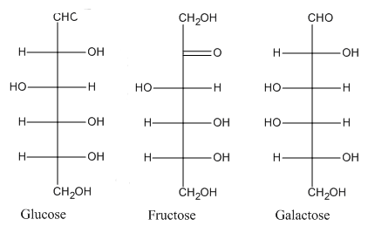
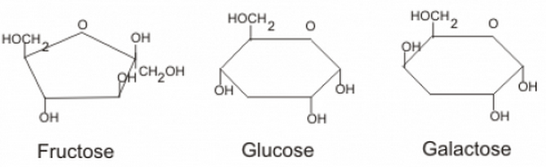
- The images below depict three of the most common monosaccharides draw in ring form, as well as drawn unjoined in a straight chain. Note that in these images where there is a corner (in the rings) and a line intersections (in the straight chain) these are meant to signify the presence of a carbon.

- Dimers (two monomers joined together) – Dimers of sugars are called disaccharides. These molecules consist of two monosaccharides joined together. The covalent bonds that form between the monosaccharides are created by dehydration synthesis and are called glycosidic linkages. Examples of disaccharides are sucrose (glucose + fructose), lactose (galactose + glucose), and maltose (glucose + glucose).

Monosaccharide + Monosaccharide → Disaccharide + Water
C₆H₁₂O₆ + C₆H₁₂O₆ → C₁₂H₂₂O₁₁ + H₂0
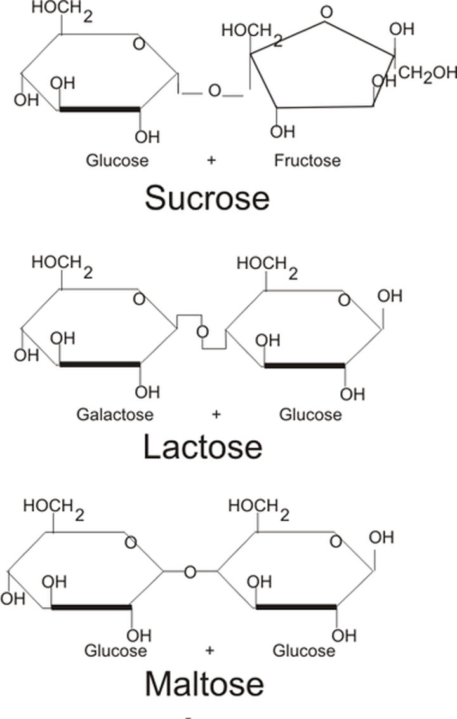

- Polymers (many monomers joined together)– Polymers of sugars are called polysaccharides. They are excellent energy storage molecules. Plants store energy in a polysaccharide called starch, and animals store energy in a polysaccharide called glycogen (kept in the liver). Plants have a polysaccharide called cellulose that is used to maintain structure in their cell walls. The external skeletons (i.e. exoskeletons) of insects and the cell walls of fungi are made of a polysaccharide called chitin, and the cell walls of some bacterial species are made of a polysaccharide called peptidoglycan. Starch, glycogen, cellulose, and chitin are all made of glucose monomers linked together in long chains, but they differ in HOW they are linked. For example, glycogen contains many branches whereas cellulose is unbranched.

 | Structural | Storage
Found in plants: | Cellulose – makes up plant cell walls | Starch – plant
Found in animals: | Chitin – makes up the exoskeleton in arthropods (and cell walls in fungi) | Glycogen – “animal starch” In humans, this is stored in liver and skeletal muscle

- Cellulose and starch are structural isomers. This means that they are compounds that have the same molecular formula [(C₆H₁₀O₅)_{n}] but different structures. Because these structures are different, the isomers have different properties as explained below.
- In the image below, the bonds between glucose monomers in starch and cellulose are shown. The glucose monomers in starch are held together by 1,4 alpha (α) linkages, which all point the same direction (i.e. down, in the picture given.) The glucose monomers in cellulose are held together by 1,4 beta (β) linkages, which point alternating directions (i.e. up, down, up, etc.) These different bonding patterns result in the starch molecule being helical (spiral shaped) and the cellulose molecule being straight. (Note: the numbers 1 and 4 simply refer to the carbon in the ring that the bond is attached to). Due to the 1,4 beta linkages in cellulose, the hydroxyl groups of a cellulose molecule are available to hydrogen bond with the hydroxyl groups of other cellulose molecules lying parallel to it. In plant cell walls, many cellulose molecules form a thick fiber, which is very strong. This structure helps cellulose perform its function, which is to provide support in plant cell walls.
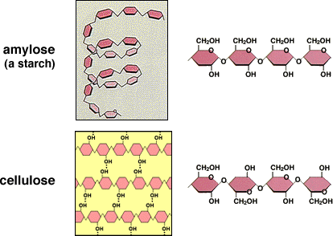
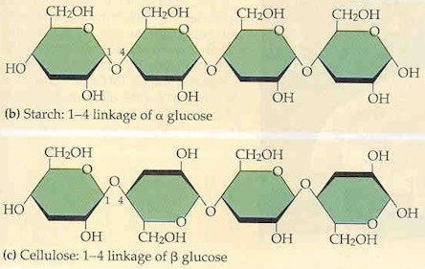
- Humans are very good at breaking down 1,4 alpha linkages to digest starch, but we are very bad at breaking down 1,4 beta linkages to digest cellulose. Therefore, when we eat a lot of cellulose, we release most of it as feces! Organisms that eat a lot of grass or cellulose-rich plant material have various adaptations for digesting cellulose. Organisms called ruminants (a group of organisms that incudes cows) have several chambers in their stomach and regurgitate their food to chew it again to better digest cellulose. Organisms called caecophores (a group of organisms that includes rabbits) eat their feces to digest their food twice and get as many nutrients as possible.

E. What are the properties of lipids?
- Elements—The elements found in lipids are many C’s and H’s and only a few O’s compared to carbohydrates which have the general formula (CH₂O)
- Functions—Lipids are used for long-term energy storage, protective coatings (ex: in the cell membrane), and insulation / maintaining warmth (ex: whale blubber). One gram of any lipid will release nine calories per gram when burned in a calorimeter (recall that carbohydrates released four calories).
- Monomers—The monomers of lipids are glycerol and fatty acids. Glycerol is a small 3-carbon molecule with hydroxyl groups branching off. Fatty acids are hydrocarbon chains with a carboxyl group at one end. Glycerol is a polar molecule (due to the hydroxyl groups), but fatty acids are nonpolar. Typically, fatty acids are so long that they “overwhelm” the polarity of the glycerol and the overall lipid molecule is considered nonpolar. The reason that lipids are grouped together is because they are all hydrophobic, because not all lipids are composed of glycerol and fatty acids.

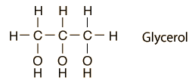 Fatty Acid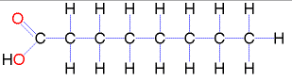

- Polymers—The polymers of lipids are fats (aka triglycerides), oils, waxes, phospholipids, and steroids. Several of these polymers are described below.
- Fats (aka triglycerides) are composed of a single glycerol molecule bonded to three fatty acid chains. When the carbons of the fatty acid chains are all single-bonded to one another, the maximum number of hydrogen atoms surround the carbons, so the fatty acids are considered “saturated” with hydrogen. Saturated fatty acid chains are straight. For this reason, saturated fats “stack” easily on top of one another to form a dense solid like butter. These fats are very unhealthy for you and can cause plaque deposits to build up in your arteries, which can result in a heart attack or stroke. These types of fats are usually come from animals. When the fatty acid chains contain one or more double bonds between carbon atoms, a smaller number of hydrogen atoms surround the carbons, so the fatty acids are considered unsaturated. Unsaturated fatty acid chains have bends or “kinks” at the location of the carbon to carbon double bonds. For this reason, unsaturated fats do not stack easily on top of one another and are usually liquid at room temperature like vegetable oil. These fats are more healthy for you and do not cause plaques to build up in your arteries and are mostly extracted from plants. One exception to this is the group of tropical oils (like coconut oil and palm oil) that are saturated, somewhat solid at room temperature and are as unhealthy as are fats extracted from animals.

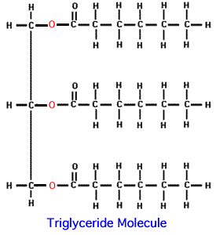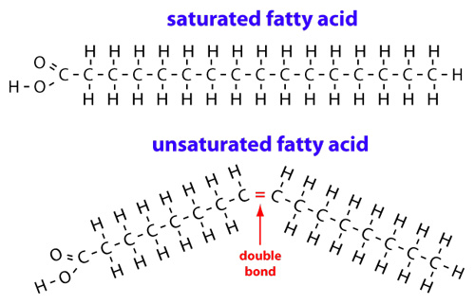

- Phospholipids are the lipid molecules found in cell membranes. They are called PHOSPHOlipids because the third hydroxyl group of the glycerol attaches to a phosphate group (instead of a fatty acid), which is charged and therefore hydrophilic. Together, the glycerol, phosphate group, and another group called choline form the polar (aka hydrophilic) “head” of the phospholipid molecule. Two fatty acid chains link to the glycerol. These chains are considered the nonpolar (aka hydrophobic) “tails” of the phospholipid molecule. Because this molecule is partly hydrophilic and partly hydrophobic it is said to be amphipathic. The fatty acid chains in phospholipids are typically unsaturated to help space the phospholipid molecules out and make the membrane more flexible. In the cell membrane, the phospholipids arrange themselves in a double layer. For this reason, the cell membrane is often called the phospholipid bilayer. The polar heads are considered “hydrophilic” (i.e. “water loving”) because they are attracted to water, so they face the water on the outside and inside the cell. The nonpolar tails are considered “hydrophobic” (i.e. “water fearing”) because they are repelled by water, so they isolate themselves on the interior of the membrane where they do not need to come in contact with water.
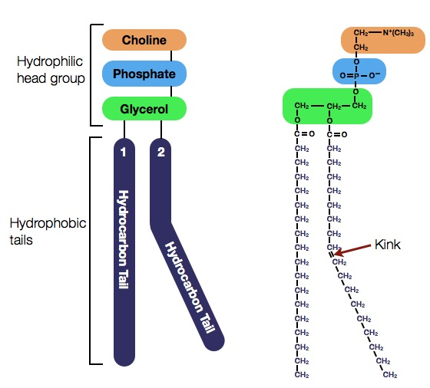
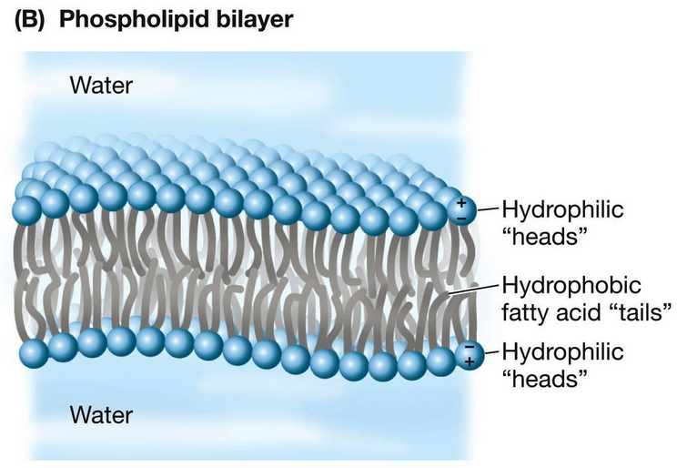

- Steroids include cholesterol and a specific group of hormone molecules (i.e. molecules used for signaling between cells in the bodies of humans and animals). Some examples of steroid hormones are testosterone and estrogen. All steroids have the same basic structure, four fused rings of carbon atoms. Different steroid molecules vary in the functional groups that are attached to these four rings. Human and plant estrogens are similar in structure, therefor when estrogen is needed in therapy, some women will prefer to take soy products in preference to estrogen from animals. Note: Not all hormones and not all vitamins are steroids.
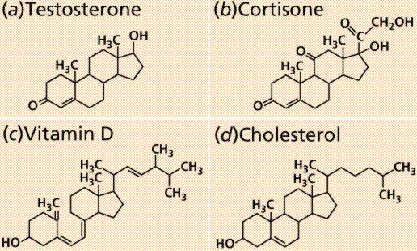

F. What are the properties of proteins?
- Elements – The elements found in proteins are C,H,O,N, and sometimes S.
- Monomers – Monomers of proteins are called amino acids. There are 20 different amino acids in nature. These molecules have a central carbon atom bonded to four things… a hydrogen atom, a carboxyl group, an amino group, and an R group (also called the side chain or variable group because it changes from amino acid to amino acid.) Depending on the atoms and functional groups present within the R group, the amino acid displays certain characteristics. For example, some amino acids are polar, some are nonpolar, some are acidic or basic, etc.

Basic Amino Acid Structure:
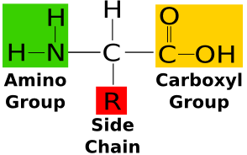

Types of Amino Acids:
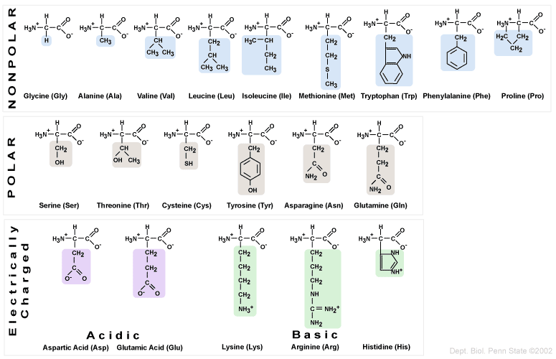

- Polymers – Polymers of proteins are called polypeptides. Polypeptides form when the carboxyl group of one amino acid bonds to the amino group of another amino acid through dehydration synthesis. This creates a covalent bond between the two amino acids that is called a peptide bond (hence the name polypeptide). The end of the polypeptide that terminates in an amino group is called the N-terminus, and the end of the polypeptide that terminates in a carboxyl group is called the C-terminus.
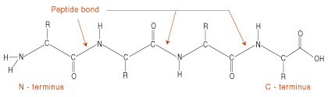

- Full Proteins – Full proteins are typically composed of multiple polypeptides folded around each other in unique conformations. The final shape of the protein gives the protein its unique function and is determined by the four levels of protein structure (detailed below).
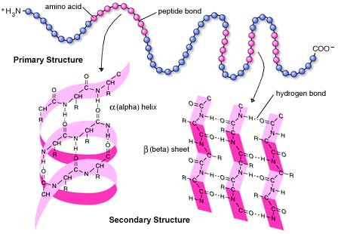
Level 1 (Primary Structure) = the order / sequence of specific amino acids in a single polypeptide of the protein

Level 2 (Secondary Structure) = when hydrogen bonds form between carboxyl groups and amino groups on non-neighboring (i.e. non-adjacent) amino acids in a single polypeptide this can result in two types of 3D structures… alpha ( α ) helices and beta ( β ) pleated sheets. Each polypeptide can have multiple helices and sheets.

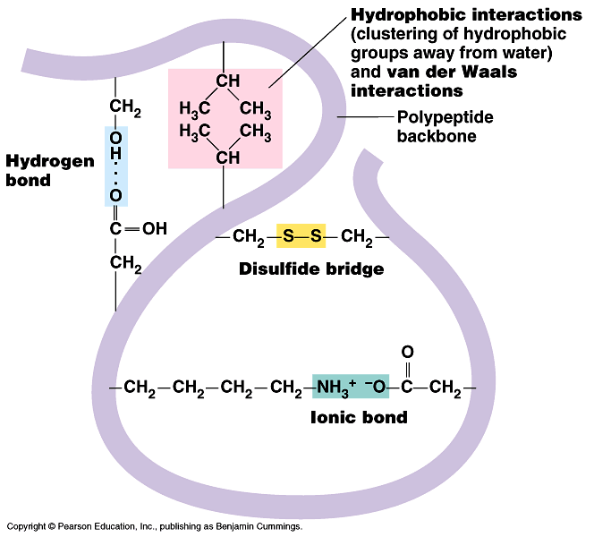
Level 3 (Tertiary Structure) = unique 3D folding patterns that occur within a single polypeptide as a result of interactions between R groups on different amino acids (see list below for the different types of interactions)

- hydrogen bonds between polar R- groups (Recall H-NOF)
- ionic bonds between charged R-groups
- hydrophobic interactions between nonpolar R-groups
- covalent bonds: The R-group of the amino acid cysteine contains a sulfur atom and this sulfur atom is capable of forming a covalent bond with another sulfur atom on a different cysteine molecule somewhere else on the chain. This bond is known as a disulfide bond and it acts as to stabilize the tertiary structure of those proteins that have such bonds.

Level 4 (Quaternary Structure) = unique 3D shapes that occur when multiple polypeptides fold around each other. This is usually the result of interactions between R groups on amino acids of DIFFERENT polypeptides (Note: the interactions for quaternary structure are the same as the interactions for tertiary structure).
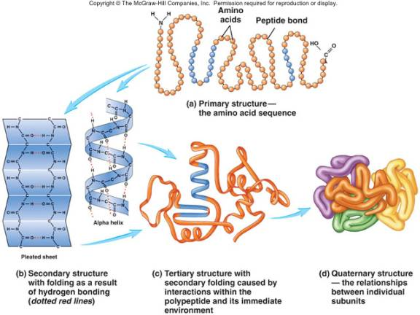

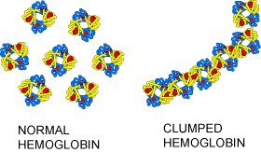
The structure / shape of full proteins determines their function. For example, a single amino acid change in the hemoglobin protein (which is used in red blood cells to bind to oxygen and carry it throughout the blood stream) results in hemoglobin molecules “clumping together”, which makes them unable to bind to oxygen efficiently. This results in the entire red blood cell having a crescent-moon shape, which is called sickle-cell disease. These abnormally shaped blood cells cannot transport oxygen efficiently and they can clog blood vessels.

When the pH changes drastically or the temperature experiences a large increase, proteins tend to lose their shape because some bonds involved secondary, tertiary, and quaternary structure are broken. Proteins that have a different overall shape can no longer perform the same function. When a protein undergoes this change, we say the protein has denatured. Remember, if you change the shape, you change the function! For example, when a chemical treatment, called a perm, is applied to hair (which is made up of the protein keratin), it can alter the secondary structure of the proteins causing their shape to change. It is also thought that the accumulation of misfolded proteins, called prions, are the cause to many serious diseases like Alzheimer’s, Parkinson’s and mad cow disease.

G. What are the properties of nucleic acids?
- Elements – The elements found in nucleic acids are C, H, O, N, and P.
- Monomers – Monomers of nucleic acids are called nucleotides. These molecules are composed of three parts—a phosphate group bonded to a 5-carbon (aka pentose sugar), which is bonded to a nitrogenous base (i.e. a molecule that contains nitrogen). There are two types of nitrogen bases—purines and pyrmidines. Purines have a double-ring structure, and pyrimidines have a single ring structure. Not all nucleotides are made into DNA or RNA polymers. For example, ATP is a nucleotide that stores large amounts of energy needed for reactions

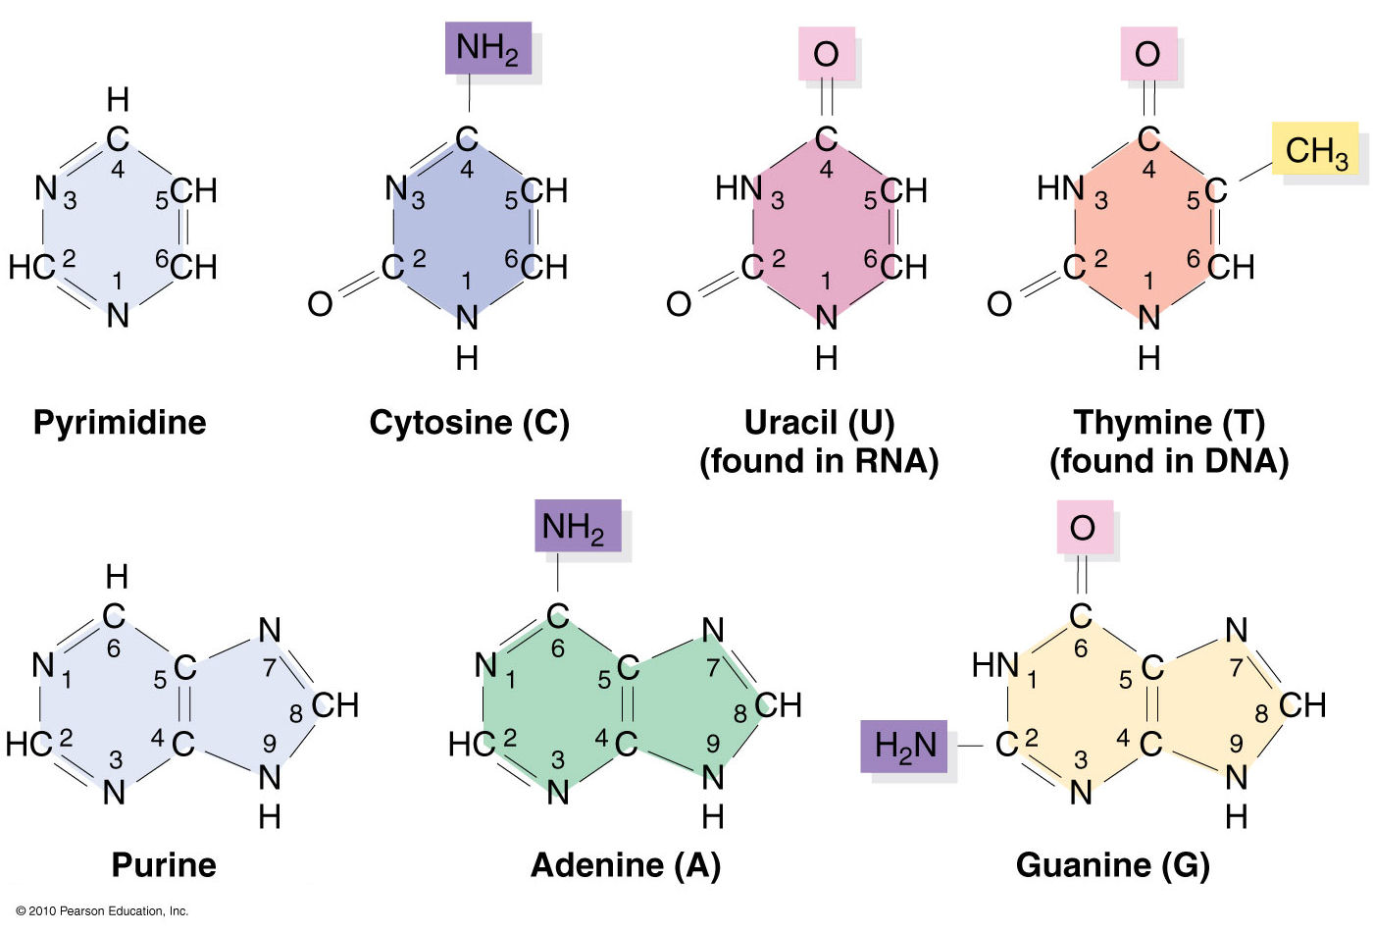
General Structure

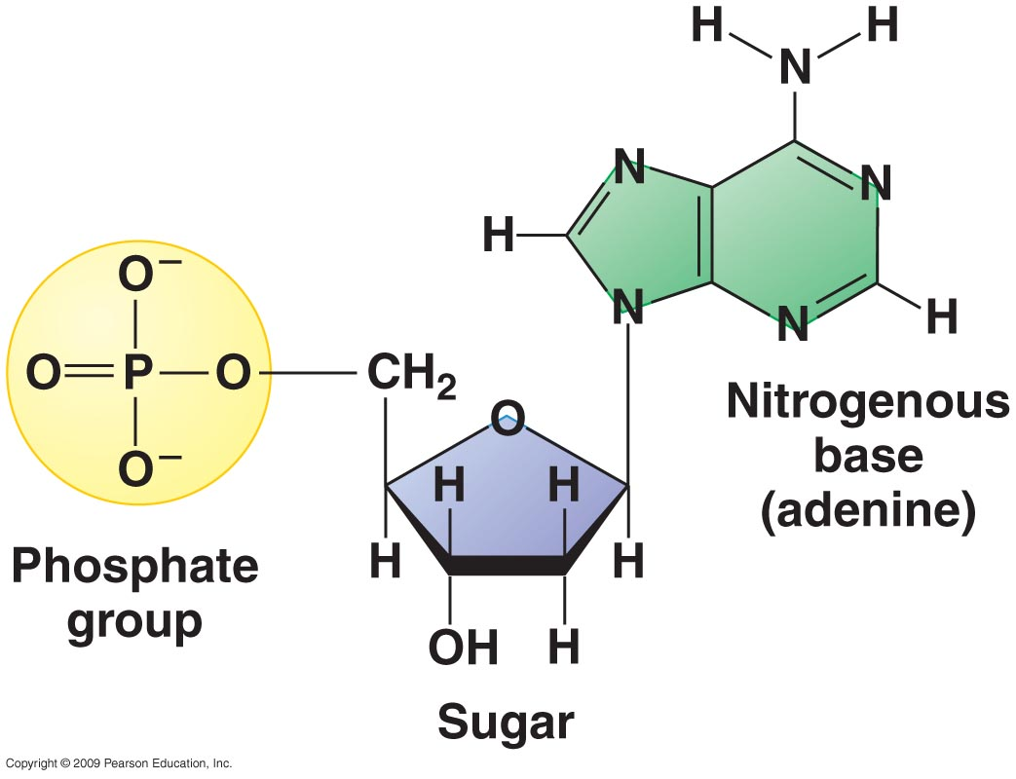

- Polymers – The two polymers of nucleic acids are DNA (deoxyribonucleic acid) and RNA (ribonucleic acid).
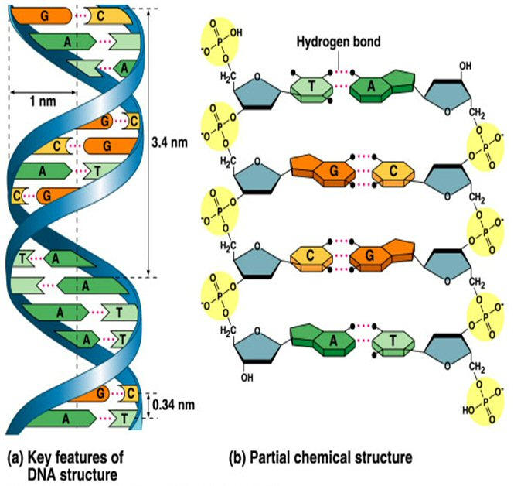
- DNA is made of two strands of nucleotides wound together in a double helix structure that appears to be a ladder when untwisted. The sides of the ladder are made of alternating phosphate groups and sugars from the nucleotides. The pentose sugar found in DNA is called deoxyribose. The sugar from one nucleotide connects to the phosphate group of the next using dehydration synthesis. The bond formed is a covalent bond called a phosphodiester linkage / bond. The nitrogen bases in DNA nucleotides are adenine (A), guanine (G), cytosine (C), and thymine (T). The nitrogen bases from one strand of nucleotides bond to nitrogen bases from the other strand across the double helix using hydrogen bonds. Purines (A and G) must always bond with pyrimidines (C and T) to maintain the width of the double helix. Adenine always bonds to thymine using two hydrogen bonds, and guanine always bonds to cytosine using three hydrogen bonds. Because they extend across the double helix, pairs of nitrogen bases form the middle / rungs of the DNA ladder.

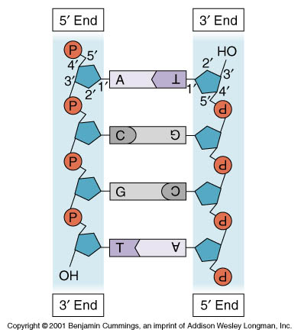
The ends of each DNA “sugar-phosphate backbone” are labeled as 5’ (five prime) or 3’ (three prime) depending on whether they end in a phosphate group or a sugar molecule. The 5’ end is the phosphate end, and the 3’ end is the sugar end. Because the sugar-phosphate backbones of the two DNA strands run in opposite directions (one runs from 5’ to 3’ and the other runs from 3’ to 5’), they are called “antiparallel.”

The sequence of nitrogen bases in DNA codes for proteins which provide certain traits within an organism. DNA is the “master copy” of genetic / hereditary information in organisms.

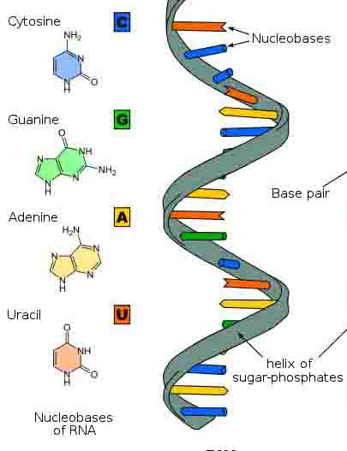
- RNA is made of one strand of nucleotides. It contains the sugar ribose rather than the deoxyribose sugar found in DNA. It contains the bases adenine (A), guanine (G), cytosine (C), and uracil (U). Uracil takes the place of the base thymine, which is found in DNA.
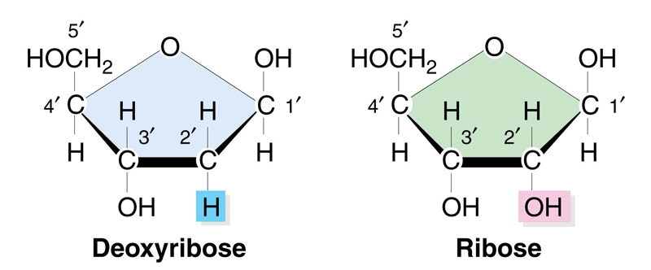

RNA is used to transmit (send) the information from DNA, which is housed in the nucleus in eukaryotic cells to the ribosome, a cell structure that makes particular proteins based on the code carried by the RNA.

Summary Table

Macromolecules | Monomers | Examples | Functions
Carbohydrates | Monosaccharides | Sugars, starch, glycogen, cellulose | Short term energy, structure
Lipids | Fatty Acid and Glycerol | Fats, Oils, Waxes, Steroids, Phospholipid | Long term energy, insulation, plasma membrane
Proteins | Amino Acids | Hemoglobin, pepsin | Enzymes, movement, structure, membrane receptors
Nucleic Acids | Nucleotides | DNA, RNA | Heredity, code for amino acid sequence

Notes Vocabulary and Questions

Vocabulary: Choose two sets of two vocabulary words from your notes. Define each term in the set and identify a connection between the two terms in the set. The definitions and connections must be in your own words and in complete sentences.

1. Terms: _______________ and _______________
Definitions and Connection:

2.Terms: _______________ and _______________
Definitions and Connection:

3. Terms: _______________ and _______________
Definitions and Connection:

4.Terms: _______________ and _______________
Definitions and Connection:

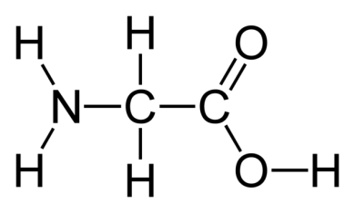

- Identify the functional groups shown in the molecule pictured to the right. Would you assume that this molecule is polar or nonpolar and why?

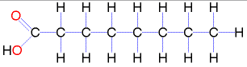
- Identify the functional groups shown in the molecule pictured to the right. Would you assume that this molecule is polar or nonpolar and why?

- Explain how estrogen and testosterone provide evidence that small changes in structure can result in large changes in function. Answer in your OWN WORDS.

- Compare and contrast dehydration synthesis and hydrolysis in the chart below.

Dehydration Synthesis Only | Similarities between Dehydration Synthesis and Hydrolysis | Hydrolysis Only

- Identify the monomers and dimer in the image below. Is this image showing dehydration synthesis or hydrolysis? How do you know?
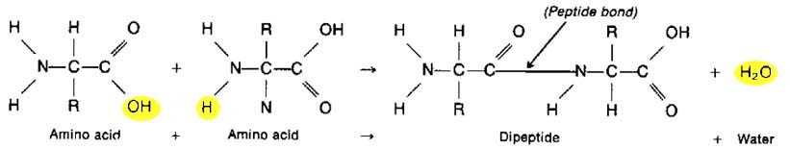

- Compare and contrast the four macromolecules using the chart below.

 | Carbohydrates | Lipids | Proteins | Nucleic Acids
Elements Present
Functions
Monomers (Name and/or Examples)
Polymers (Name and/or Examples)

- Explain how the structure of cellulose contributes to its function.

- Label the glycerol and fatty acids in the image of a fat (aka triglyceride) shown below. Is this a saturated or unsaturated fat, and how do you know?
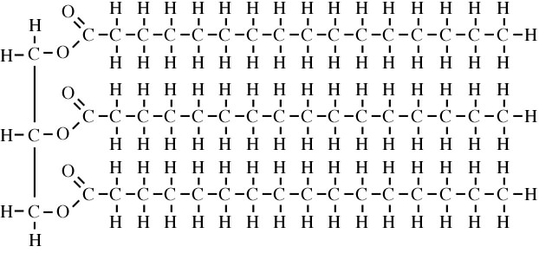

- How do phospholipid molecules arrange themselves in the cell membrane? Explain why they arrange themselves in this way, and draw a picture of the cell membrane in the box given below.

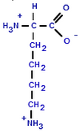
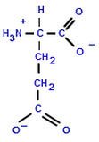
- What type of bond will form between amino acids with R groups that have opposite charges? See images of both amino acids below.

- In the image below of a polypeptide, label the following components: the N-terminus, the C-terminus, a peptide bond, a carboxyl group, an amino group, an R group, a central carbon atom, and a single amino acid.

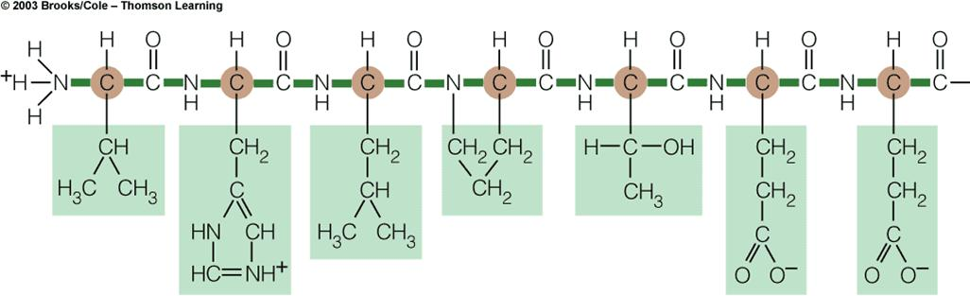

- Identify the level of protein structure shown in each of the images below (i.e., primary, secondary, tertiary, or quaternary structure), and provide an explanation for your choice.

Image | Level of Structure | Explanation
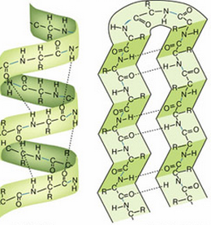
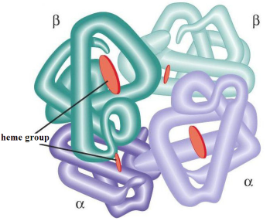
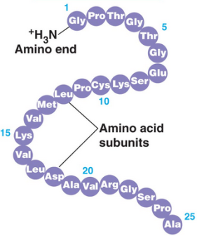
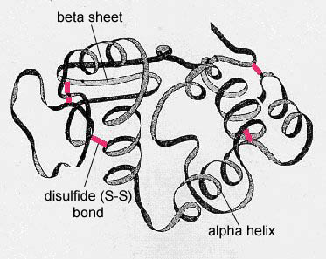

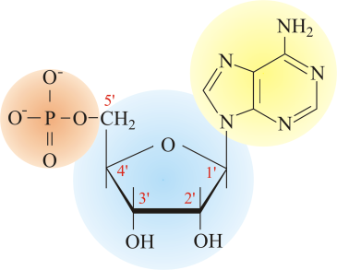
- Label the parts of the nucleotide picture to the right.

